Java Hello World Program
A "Hello, World!" is a simple program that outputs Hello, World! on the screen. Since it's a very simple program, it's often used to introduce a new programming language to a newbie.

Java "Hello, World!" Program
// First Program

class HelloWorld {
public static void main(String[] args) {
System.out.println("Hello, World!");
}
}
Output
Hello, World!

How Java "Hello, World!" Program Works?
- // First Program
In Java, any line starting with // is a comment. Comments are intended for users reading the code to understand the intent and functionality of the program. It is completely ignored by the Java compiler (an application that translates Java program to Java bytecode that computer can execute).
- class HelloWorld { ... }
In Java, every application begins with a class definition. In the program, HelloWorld is the name of the class, and the class definition is:
- class HelloWorld {
- ... .. ...
}
Every Java application has a class definition, and the name of the class should match the filename in Java.
- public static void main(String[] args) { ... }
This is the main method. Every application in Java must contain the main method. The Java compiler starts executing the code from the main method.
main function is the entry point of Java application, and it's mandatory in a Java program. The signature of the main method in Java is:
- public static void main(String[] args) {
- ... .. ...
}
- System.out.println("Hello, World!");
The code above is a print statement. It prints the text Hello, World! to standard output (your screen).
- the print statement is inside the main function, which is inside the class definition.
- Every valid Java Application must have a class definition (that matches the filename).
- The main method must be inside the class definition.
- The compiler executes the codes starting from the main function.

Java JDK, JRE and JVM

What is JVM?
JVM (Java Virtual Machine) is an abstract machine that enables your computer to run a Java program.
When you run the Java program, Java compiler first compiles your Java code to bytecode. Then, the JVM translates bytecode into native machine code (set of instructions that a computer's CPU executes directly).
Java is a platform-independent language. It's because when you write Java code, it's ultimately written for JVM but not your physical machine (computer). Since JVM ​executes the Java bytecode which is platform-independent, Java is platform-independent.
Working of Java Program

What is JRE?
JRE (Java Runtime Environment) is a software package that provides Java class libraries, Java Virtual Machine (JVM), and other components that are required to run Java applications.
JRE is the superset of JVM.

Java Runtime Environment
If you need to run Java programs, but not develop them, JRE is what you need.

What is JDK?
JDK (Java Development Kit) is a software development kit required to develop applications in Java. When you download JDK, JRE is also downloaded with it.
In addition to JRE, JDK also contains a number of development tools (compilers, JavaDoc, Java Debugger, etc).
Java Development Kit

Relationship between JVM, JRE, and JDK.
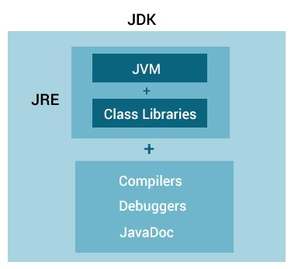
Relationship between JVM, JRE, and JDK

Java Variables and Literals

Java Variables
A variable is a location in memory (storage area) to hold data.
To indicate the storage area, each variable should be given a unique name (identifier).

Create Variables in Java
int speedLimit = 80;
Here, speedLimit is a variable of int data type and we have assigned value 80 to it.
The int data type suggests that the variable can only hold integers.
In the example, we have assigned value to the variable during declaration. However, it's not mandatory.
You can declare variables and assign variables separately. For example,
int speedLimit;
speedLimit = 80;
Java is a statically-typed language. It means that all variables must be declared before they can be used.

Change values of variables
The value of a variable can be changed in the program, hence the name variable. For example,
int speedLimit = 80;
... .. ...
speedLimit = 90;
Here, initially, the value of speedLimit is 80. Later, we changed it to 90.
However, we cannot change the data type of a variable in Java within the same scope.

Rules for Naming Variables in Java
Java programming language has its own set of rules and conventions for naming variables. Here's what you need to know:
- Java is case sensitive. Hence, age and AGE are two different variables. For example,
- int age = 24;
- int AGE = 25;

- System.out.println(age); // prints 24
System.out.println(AGE); // prints 25
- Variables must start with either a letter or an underscore, _ or a dollar, $ sign. For example,
- int age; // valid name and good practice
- int _age; // valid but bad practice
int $age; // valid but bad practice
- Variable names cannot start with numbers. For example,
int 1age; // invalid variables
- Variable names can't use whitespace. For example,
int my age; // invalid variables
Here, is we need to use variable names having more than one word, use all lowercase letters for the first word and capitalize the first letter of each subsequent word. For example, myAge.
- When creating variables, choose a name that makes sense. For example, score, number, level makes more sense than variable names such as s, n, and l.
- If you choose one-word variable names, use all lowercase letters. For example, it's better to use speed rather than SPEED, or sPEED.
There are 4 types of variables in Java programming language:
- Instance Variables (Non-Static Fields)
- Class Variables (Static Fields)
- Local Variables
- Parameters

Java literals
Literals are data used for representing fixed values. They can be used directly in the code. For example,
int a = 1;
float b = 2.5;
char c = 'F';
Here, 1, 2.5, and 'F' are literals.
Here are different types of literals in Java.

1. Boolean Literals
In Java, boolean literals are used to initialize boolean data types. They can store two values: true and false. For example,
boolean flag1 = false;
boolean flag2 = true;
Here, false and true are two boolean literals.

2. Integer Literals
An integer literal is a numeric value(associated with numbers) without any fractional or exponential part. There are 4 types of integer literals in Java:
- binary (base 2)
- decimal (base 10)
- octal (base 8)
- hexadecimal (base 16)
For example:
// binary
int binaryNumber = 0b10010;
// octal
int octalNumber = 027;

// decimal
int decNumber = 34;

// hexadecimal
int hexNumber = 0x2F; // 0x represents hexadecimal
// binary
int binNumber = 0b10010; // 0b represents binary
In Java, binary starts with 0b, octal starts with 0, and hexadecimal starts with 0x.
Integer literals are used to initialize variables of integer types like byte, short, int, and long.

3. Floating-point Literals
A floating-point literal is a numeric literal that has either a fractional form or an exponential form. For example,
class Main {
public static void main(String[] args) {

double myDouble = 3.4;
float myFloat = 3.4F;

// 3.445*10^2
double myDoubleScientific = 3.445e2;

System.out.println(myDouble); // prints 3.4
System.out.println(myFloat); // prints 3.4
System.out.println(myDoubleScientific); // prints 344.5
} }
The floating-point literals are used to initialize float and double type variables.

4. Character Literals
Character literals are unicode character enclosed inside single quotes. For example,
char letter = 'a';
Here, a is the character literal.
We can also use escape sequences as character literals. For example, \b (backspace), \t (tab), \n (new line), etc.

5. String literals
A string literal is a sequence of characters enclosed inside double-quotes. For example,
String str1 = "Java Programming";
String str2 = "Programiz";
Here, Java Programming and Programiz are two string literals.

Java Data Types (Primitive)

Java Data Types
As the name suggests, data types specify the type of data that can be stored inside variables in Java.
Java is a statically-typed language. This means that all variables must be declared before they can be used.
int speed;
Here, speed is a variable, and the data type of the variable is int.
The int data type determines that the speed variable can only contain integers.
There are 8 data types predefined in Java, known as primitive data types.
In addition to primitive data types, there are also referenced types (object type).

8 Primitive Data Types

1. boolean type
- The boolean data type has two possible values, either true or false.
- Default value: false.
- They are usually used for true/false conditions.

Example 1: Java boolean data type
class Main {
public static void main(String[] args) {

boolean flag = true;
System.out.println(flag); // prints true
}
}

2. byte type
- The byte data type can have values from -128 to 127 (8-bit signed two's complement integer).
- If it's certain that the value of a variable will be within -128 to 127, then it is used instead of int to save memory.
- Default value: 0

Example 2: Java byte data type
class Main {
public static void main(String[] args) {

byte range;
range = 124;
System.out.println(range); // prints 124
}
}

3. short type
- The short data type in Java can have values from -32768 to 32767 (16-bit signed two's complement integer).
- If it's certain that the value of a variable will be within -32768 and 32767, then it is used instead of other integer data types (int, long).
- Default value: 0

Example 3: Java short data type
class Main {
public static void main(String[] args) {

short temperature;
temperature = -200;
System.out.println(temperature); // prints -200
}
}

4. int type
- The int data type can have values from -2³¹ to 2³¹-1 (32-bit signed two's complement integer).
- If you are using Java 8 or later, you can use an unsigned 32-bit integer. This will have a minimum value of 0 and a maximum value of 2³²-1.
- Default value: 0

Example 4: Java int data type
class Main {
public static void main(String[] args) {

int range = -4250000;
System.out.println(range); // print -4250000
}
}

5. long type
- The long data type can have values from -2⁶³ to 2⁶³-1 (64-bit signed two's complement integer).
- If you are using Java 8 or later, you can use an unsigned 64-bit integer with a minimum value of 0 and a maximum value of 2⁶⁴-1.
- Default value: 0

Example 5: Java long data type
class LongExample {
public static void main(String[] args) {

long range = -42332200000L;
System.out.println(range); // prints -42332200000
}
}
Notice, the use of L at the end of -42332200000. This represents that it's an integer of the long type.

6. double type
- The double data type is a double-precision 64-bit floating-point.
- It should never be used for precise values such as currency.
- Default value: 0.0 (0.0d)

Example 6: Java double data type
class Main {
public static void main(String[] args) {

double number = -42.3;
System.out.println(number); // prints -42.3
}
}

7. float type
- The float data type is a single-precision 32-bit floating-point.
- It should never be used for precise values such as currency.
- Default value: 0.0 (0.0f)

Example 7: Java float data type
class Main {
public static void main(String[] args) {

float number = -42.3f;
System.out.println(number); // prints -42.3
}
}
Notice that we have used -42.3f instead of -42.3in the above program. It's because -42.3 is a double literal.
To tell the compiler to treat -42.3 as float rather than double, you need to use f or F.

8. char type
- It's a 16-bit Unicode character.
- The minimum value of the char data type is '\u0000' (0) and the maximum value of the is '\uffff'.
- Default value: '\u0000'

Example 8: Java char data type
class Main {
public static void main(String[] args) {

char letter = '\u0051';
System.out.println(letter); // prints Q
}
}
Here, the Unicode value of Q is \u0051. Hence, we get Q as the output.
Here is another example:
class Main {
public static void main(String[] args) {

char letter1 = '9';
System.out.println(letter1); // prints 9

char letter2 = 65;
System.out.println(letter2); // prints A

}
}
Here, we have assigned 9 as a character (specified by single quotes) to the letter1 variable. However, the letter2 variable is assigned 65 as an integer number (no single quotes).
Hence, A is printed to the output. It is because Java treats characters as an integer and the ASCII value of A is 65.

String type
Java also provides support for character strings via java.lang.String class. Strings in Java are not primitive types. Instead, they are objects. For example,
String myString = "Java Programming";
Here, myString is an object of the String class.

Java Operators
Operators are symbols that perform operations on variables and values. For example, + is an operator used for addition, while * is also an operator used for multiplication.
Operators in Java can be classified into 5 types:
- Arithmetic Operators
- Assignment Operators
- Relational Operators
- Logical Operators
- Unary Operators
- Bitwise Operators
1. Java Arithmetic Operators
Arithmetic operators are used to perform arithmetic operations on variables and data. For example,
a + b;
Here, the + operator is used to add two variables a and b. Similarly, there are various other arithmetic operators in Java.
Operator | Operation
+ | Addition
- | Subtraction
* | Multiplication
/ | Division
% | Modulo Operation (Remainder after division)

Example 1: Arithmetic Operators
class Main {
public static void main(String[] args) {

// declare variables
int a = 12, b = 5;

// addition operator
System.out.println("a + b = " + (a + b));

// subtraction operator
System.out.println("a - b = " + (a - b));

// multiplication operator
System.out.println("a * b = " + (a * b));

// division operator
System.out.println("a / b = " + (a / b));

// modulo operator
System.out.println("a % b = " + (a % b));
}
}
Output
a + b = 17
a - b = 7
a * b = 60
a / b = 2
a % b = 2
In the above example, we have used +, -, and * operators to compute addition, subtraction, and multiplication operations.
/ Division Operator
Note the operation, a / b in our program. The / operator is the division operator.
If we use the division operator with two integers, then the resulting quotient will also be an integer. And, if one of the operands is a floating-point number, we will get the result will also be in floating-point.
In Java,

(9 / 2) is 4
(9.0 / 2) is 4.5
(9 / 2.0) is 4.5
(9.0 / 2.0) is 4.5
% Modulo Operator
The modulo operator % computes the remainder. When a = 7 is divided by b = 4, the remainder is 3.
The % operator is mainly used with integers.

2. Java Assignment Operators
Assignment operators are used in Java to assign values to variables. For example,
int age;
age = 5;
Here, = is the assignment operator. It assigns the value on its right to the variable on its left. That is, 5 is assigned to the variable age.
Let's see some more assignment operators available in Java.
Operator | Example | Equivalent to
= | a = b; | a = b;
+= | a += b; | a = a + b;
-= | a -= b; | a = a - b;
*= | a *= b; | a = a * b;
/= | a /= b; | a = a / b;
%= | a %= b; | a = a % b;

Example 2: Assignment Operators
class Main {
public static void main(String[] args) {

// create variables
int a = 4;
int var;

// assign value using =
var = a;
System.out.println("var using =: " + var);

// assign value using =+
var += a;
System.out.println("var using +=: " + var);

// assign value using =*
var *= a;
System.out.println("var using *=: " + var);
}
}
Output
var using =: 4
var using +=: 8
var using *=: 32

3. Java Relational Operators
Relational operators are used to check the relationship between two operands. For example,
// check if a is less than b
a < b;
Here, < operator is the relational operator. It checks if a is less than b or not.
It returns either true or false.
Operator | Description | Example
== | Is Equal To | 3 == 5 returns false
!= | Not Equal To | 3 != 5 returns true
> | Greater Than | 3 > 5 returns false
< | Less Than | 3 < 5 returns true
>= | Greater Than or Equal To | 3 >= 5 returns false
<= | Less Than or Equal To | 3 <= 5 returns true

Example 3: Relational Operators
class Main {
public static void main(String[] args) {

// create variables
int a = 7, b = 11;

// value of a and b
System.out.println("a is " + a + " and b is " + b);

// == operator
System.out.println(a == b); // false

// != operator
System.out.println(a != b); // true

// > operator
System.out.println(a > b); // false

// < operator
System.out.println(a < b); // true

// >= operator
System.out.println(a >= b); // false

// <= operator
System.out.println(a <= b); // true
}
}
Relational operators are used in decision making and loops.

4. Java Logical Operators
Logical operators are used to check whether an expression is true or false. They are used in decision making.
Operator | Example | Meaning
&& (Logical AND) | expression1 && expression2 | true only if both expression1 and expression2 are true
|| (Logical OR) | expression1 || expression2 | true if either expression1 or expression2 is true
! (Logical NOT) | !expression | true if expression is false and vice versa

Example 4: Logical Operators
class Main {
public static void main(String[] args) {

// && operator
System.out.println((5 > 3) && (8 > 5)); // true
System.out.println((5 > 3) && (8 < 5)); // false

// || operator
System.out.println((5 < 3) || (8 > 5)); // true
System.out.println((5 > 3) || (8 < 5)); // true
System.out.println((5 < 3) || (8 < 5)); // false

// ! operator
System.out.println(!(5 == 3)); // true
System.out.println(!(5 > 3)); // false
}
}
Working of Program
- (5 > 3) && (8 > 5) returns true because both (5 > 3) and (8 > 5) are true.
- (5 > 3) && (8 < 5) returns false because the expression (8 < 5) is false.
- (5 < 3) || (8 > 5) returns true because the expression (8 > 5) is true.
- (5 > 3) && (8 > 5) returns true because the expression (5 > 3) is true.
- (5 > 3) && (8 > 5) returns false because both (5 < 3) and (8 < 5) are false.
- !(5 == 3) returns true because 5 == 3 is false.
- !(5 > 3) returns false because 5 > 3 is true.

5. Java Unary Operators
Unary operators are used with only one operand. For example, ++ is a unary operator that increases the value of a variable by 1. That is, ++5 will return 6.
Different types of unary operators are:
Operator | Meaning
+ | Unary plus: not necessary to use since numbers are positive without using it
- | Unary minus: inverts the sign of an expression
++ | Increment operator: increments value by 1
-- | Decrement operator: decrements value by 1
! | Logical complement operator: inverts the value of a boolean

Increment and Decrement Operators
Java also provides increment and decrement operators: ++ and -- respectively. ++ increases the value of the operand by 1, while -- decrease it by 1. For example,
int num = 5;

// increase num by 1
++num;
Here, the value of num gets increased to 6 from its initial value of 5.

Example 5: Increment and Decrement Operators
class Main {
public static void main(String[] args) {

// declare variables
int a = 12, b = 12;
int result1, result2;

// original value
System.out.println("Value of a: " + a);

// increment operator
result1 = ++a;
System.out.println("After increment: " + result1);

System.out.println("Value of b: " + b);

// decrement operator
result2 = --b;
System.out.println("After decrement: " + result2);
}
}
Output
Value of a: 12
After increment: 13
Value of b: 12
After decrement: 11
In the above program, we have used the ++ and -- operator as prefixes (++a, --b). We can also use these operators as postfix (a++, b++).
There is a slight difference when these operators are used as prefix versus when they are used as a postfix.

6. Java Bitwise Operators
Bitwise operators in Java are used to perform operations on individual bits. For example,
Bitwise complement Operation of 35

35 = 00100011 (In Binary)

~ 00100011
________
11011100 = 220 (In decimal)
Here, ~ is a bitwise operator. It inverts the value of each bit (0 to 1 and 1 to 0).
The various bitwise operators present in Java are:
Operator | Description
~ | Bitwise Complement
<< | Left Shift
>> | Right Shift
>>> | Unsigned Right Shift
& | Bitwise AND
^ | Bitwise exclusive OR

Other operators
Besides these operators, there are other additional operators in Java.

Java instanceof Operator
The instanceof operator checks whether an object is an instanceof a particular class. For example,
class Main {
public static void main(String[] args) {

String str = "Programiz";
boolean result;

// checks if str is an instance of
// the String class
result = str instanceof String;
System.out.println("Is str an object of String? " + result);
}
}
Output
Is str an object of String? true
Here, str is an instance of the String class. Hence, the instanceof operator returns true.

Java Ternary Operator
The ternary operator (conditional operator) is shorthand for the if-then-else statement. For example,
variable = Expression ? expression1 : expression2
Here's how it works.
- If the Expression is true, expression1 is assigned to the variable.
- If the Expression is false, expression2 is assigned to the variable.
Let's see an example of a ternary operator.
class Java {
public static void main(String[] args) {

int februaryDays = 29;
String result;

// ternary operator
result = (februaryDays == 28) ? "Not a leap year" : "Leap year";
System.out.println(result);
}
}
Output
Leap year
In the above example, we have used the ternary operator to check if the year is a leap year or not.

Java Basic Input and Output

Java Output
In Java, you can simply use
System.out.println(); or

System.out.print(); or

System.out.printf();
to send output to standard output (screen).
Here,
- System is a class
- out is a public static field: it accepts output data.
Don't worry if you don't understand it. We will discuss class, public, and static in later chapters.
Let's take an example to output a line.
class AssignmentOperator {
public static void main(String[] args) {

System.out.println("Java programming is interesting.");
}
}
Output:
Java programming is interesting.
Here, we have used the println() method to display the string.

Difference between println(), print() and printf()
- print() - It prints string inside the quotes.
- println() - It prints string inside the quotes similar like print() method. Then the cursor moves to the beginning of the next line.
- printf() - It provides string formatting (similar to printf in C/C++ programming).

Example: print() and println()
class Output {
public static void main(String[] args) {

System.out.println("1. println ");
System.out.println("2. println ");

System.out.print("1. print ");
System.out.print("2. print");
}
}
Output:
1. println
2. println
1. print 2. print
In the above example, we have shown the working of the print() and println() methods. To learn about the printf() method, visit Java printf().

Example: Printing Variables and Literals
class Variables {
public static void main(String[] args) {

Double number = -10.6;

System.out.println(5);
System.out.println(number);
}
}
When you run the program, the output will be:
5
-10.6
Here, you can see that we have not used the quotation marks. It is because to display integers, variables and so on, we don't use quotation marks.

Example: Print Concatenated Strings
class PrintVariables {
public static void main(String[] args) {

Double number = -10.6;

System.out.println("I am " + "awesome.");
System.out.println("Number = " + number);
}
}
Output:
I am awesome.
Number = -10.6
In the above example, notice the line,
System.out.println("I am " + "awesome.");
Here, we have used the + operator to concatenate (join) the two strings: "I am " and "awesome.".
And also, the line,
System.out.println("Number = " + number);
Here, first the value of variable number is evaluated. Then, the value is concatenated to the string: "Number = ".

Java Input
Java provides different ways to get input from the user. However, in this tutorial, you will learn to get input from user using the object of Scanner class.
In order to use the object of Scanner, we need to import java.util.Scanner package.

import java.util.Scanner;
Then, we need to create an object of the Scanner class. We can use the object to take input from the user.

// create an object of Scanner
Scanner input = new Scanner(System.in);

// take input from the user
int number = input.nextInt();

Example: Get Integer Input From the User
import java.util.Scanner;

class Input {
public static void main(String[] args) {

Scanner input = new Scanner(System.in);

System.out.print("Enter an integer: ");
int number = input.nextInt();
System.out.println("You entered " + number);

// closing the scanner object
input.close();
}
}
Output:
Enter an integer: 23
You entered 23
In the above example, we have created an object named input of the Scanner class. We then call the nextInt() method of the Scanner class to get an integer input from the user.
Similarly, we can use nextLong(), nextFloat(), nextDouble(), and next() methods to get long, float, double, and string input respectively from the user.
We have used the close() method to close the object. It is recommended to close the scanner object once the input is taken.

Example: Get float, double and String Input
import java.util.Scanner;

class Input {
public static void main(String[] args) {

Scanner input = new Scanner(System.in);

// Getting float input
System.out.print("Enter float: ");
float myFloat = input.nextFloat();
System.out.println("Float entered = " + myFloat);

// Getting double input
System.out.print("Enter double: ");
double myDouble = input.nextDouble();
System.out.println("Double entered = " + myDouble);

// Getting String input
System.out.print("Enter text: ");
String myString = input.next();
System.out.println("Text entered = " + myString);
}
}
Output:
Enter float: 2.343
Float entered = 2.343
Enter double: -23.4
Double entered = -23.4
Enter text: Hey!
Text entered = Hey!
As mentioned, there are other several ways to get input from the user.

Java Expressions, Statements and Blocks

Java Expressions
A Java expression consists of variables, operators, literals, and method calls. For example,
int score;
score = 90;
Here, score = 90 is an expression that returns an int. Consider another example,
Double a = 2.2, b = 3.4, result;
result = a + b - 3.4;
Here, a + b - 3.4 is an expression.
if (number1 == number2)
System.out.println("Number 1 is larger than number 2");
Here, number1 == number2 is an expression that returns a boolean value. Similarly, "Number 1 is larger than number 2" is a string expression.

Java Statements
In Java, each statement is a complete unit of execution. For example,
int score = 9*5;
Here, we have a statement. The complete execution of this statement involves multiplying integers 9 and 5 and then assigning the result to the variable score.
In the above statement, we have an expression 9 * 5. In Java, expressions are part of statements.

Expression statements
We can convert an expression into a statement by terminating the expression with a ;. These are known as expression statements. For example,
// expression
number = 10
// statement
number = 10;
In the above example, we have an expression number = 10. Here, by adding a semicolon (;), we have converted the expression into a statement (number = 10;).
Consider another example,
// expression
++number
// statement
++number;
Similarly, ++number is an expression whereas ++number; is a statement.

Declaration Statements
In Java, declaration statements are used for declaring variables. For example,
Double tax = 9.5;
The statement above declares a variable tax which is initialized to 9.5.
There are control flow statements that are used in decision making and looping in Java. You will learn about control flow statements in later chapters.

Java Blocks
A block is a group of statements (zero or more) that is enclosed in curly braces { }. For example,
class Main {
public static void main(String[] args) {

String band = "Beatles";

if (band == "Beatles") { // start of block
System.out.print("Hey ");
System.out.print("Jude!");
} // end of block
}
}
Output:
Hey Jude!
In the above example, we have a block if {....}.
Here, inside the block we have two statements:
- System.out.print("Hey ");
- System.out.print("Jude!");
However, a block may not have any statements. Consider the following examples,

class Main {
public static void main(String[] args) {

if (10 > 5) { // start of block

} // end of block
}
}
This is a valid Java program. Here, we have a block if {...}. However, there is no any statement inside this block.
class AssignmentOperator {
public static void main(String[] args) { // start of block

} // end of block
}
Here, we have block public static void main() {...}. However, similar to the above example, this block does not have any statement.

Java Comments
In computer programming, comments are a portion of the program that are completely ignored by Java compilers. They are mainly used to help programmers to understand the code. For example,
// declare and initialize two variables
int a =1;
int b = 3;

// print the output
System.out.println("This is output");
Here, we have used the following comments,
- declare and initialize two variables
- print the output

Types of Comments in Java
In Java, there are two types of comments:
- single-line comment
- multi-line comment

Single-line Comment
A single-line comment starts and ends in the same line. To write a single-line comment, we can use the // symbol. For example,
// "Hello, World!" program example

class Main {
public static void main(String[] args) {
{
// prints "Hello, World!"
System.out.println("Hello, World!");
}
}
Output:
Hello, World!
Here, we have used two single-line comments:
- "Hello, World!" program example
- prints "Hello World!"
The Java compiler ignores everything from // to the end of line. Hence, it is also known as End of Line comment.

Multi-line Comment
When we want to write comments in multiple lines, we can use the multi-line comment. To write multi-line comments, we can use the /*....*/ symbol. For example,
/* This is an example of multi-line comment.
* The program prints "Hello, World!" to the standard output.
*/

class HelloWorld {
public static void main(String[] args) {
{
System.out.println("Hello, World!");
}
}
Output:
Hello, World!
Here, we have used the multi-line comment:
/* This is an example of multi-line comment.
* The program prints "Hello, World!" to the standard output.
*/
This type of comment is also known as Traditional Comment. In this type of comment, the Java compiler ignores everything from /* to */.

Use Comments the Right Way
One thing you should always consider that comments shouldn't be the substitute for a way to explain poorly written code in English. You should always write well structured and self explaining code. And, then use comments.
Some believe that code should be self-describing and comments should be rarely used. However, in my personal opinion, there is nothing wrong with using comments. We can use comments to explain complex algorithms, regex or scenarios where we have to choose one technique among different technique to solve problems.

Java if...else Statement
In this tutorial, you will learn about control flow statements using Java if and if...else statements with the help of examples.
In programming, we use the if..else statement to run a block of code among more than one alternatives.
For example, assigning grades (A, B, C) based on the percentage obtained by a student.
- if the percentage is above 90, assign grade A
- if the percentage is above 75, assign grade B
- if the percentage is above 65, assign grade C

1. Java if (if-then) Statement
The syntax of an if-then statement is:
if (condition) {
// statements
}
Here, condition is a boolean expression such as age >= 18.
- if condition evaluates to true, statements are executed
- if condition evaluates to false, statements are skipped

Working of if Statement
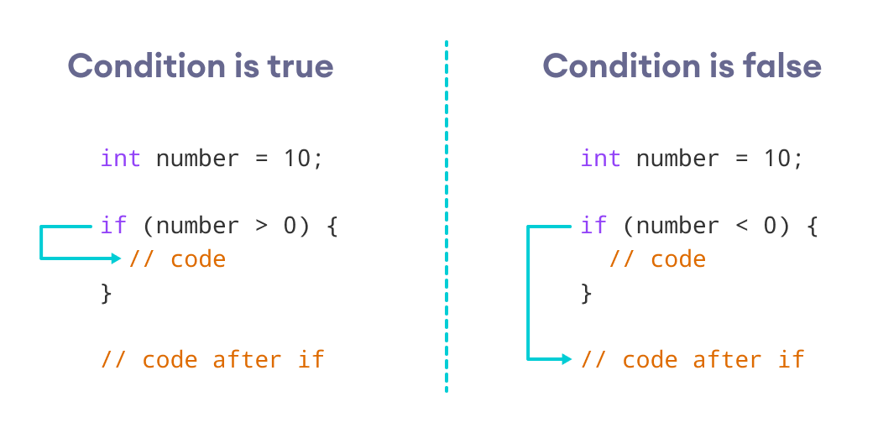
Working of Java if statement

Example 1: Java if Statement
class IfStatement {
public static void main(String[] args) {

int number = 10;

// checks if number is less than 0
if (number < 0) {
System.out.println("The number is negative.");
}

System.out.println("Statement outside if block");
}
}
Output
Statement outside if block
In the program, number < 0 is false. Hence, the code inside the parenthesis is skipped.
We can also use Java Strings as the test condition.

Example 2: Java if with String
class Main {
public static void main(String[] args) {
// create a string variable
String language = "Java";

// if statement
if (language == "Java") {
System.out.println("Best Programming Language");
}
}
}
Output
Best Programming Language
In the above example, we are comparing two strings in the if block.

2. Java if...else (if-then-else) Statement
The if statement executes a certain section of code if the test expression is evaluated to true. However, if the test expression is evaluated to false, it does nothing.
In this case, we can use an optional else block. Statements inside the body of else block are executed if the test expression is evaluated to false. This is known as the if-...else statement in Java.
The syntax of the if...else statement is:
if (condition) {
// codes in if block
}
else {
// codes in else block
}
Here, the program will do one task (codes inside if block) if the condition is true and another task (codes inside else block) if the condition is false.

How the if...else statement works?
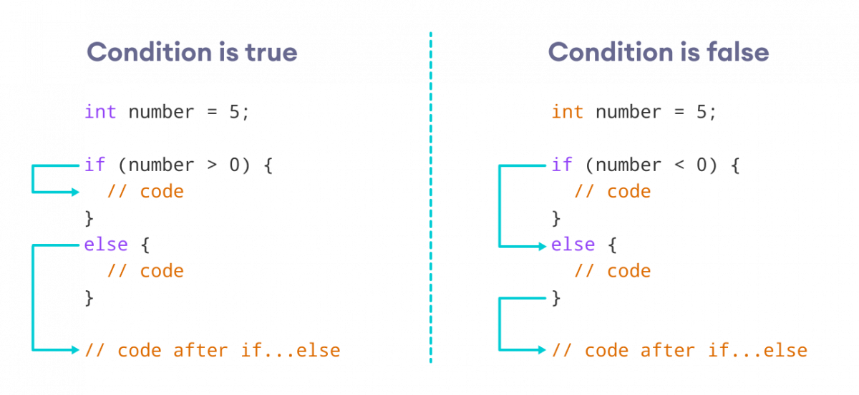Working of Java if-else statements

Example 3: Java if...else Statement
class Main {
public static void main(String[] args) {
int number = 10;

// checks if number is greater than 0
if (number > 0) {
System.out.println("The number is positive.");
}

// execute this block
// if number is not greater than 0
else {
System.out.println("The number is not positive.");
}

System.out.println("Statement outside if...else block");
}
}
Output
The number is positive.
Statement outside if...else block
In the above example, we have a variable named number. Here, the test expression number > 0 checks if number is greater than 0.
Since the value of the number is 10, the test expression evaluates to true. Hence code inside the body of if is executed.
Now, change the value of the number to a negative integer. Let's say -5.
int number = -5;
If we run the program with the new value of number, the output will be:
The number is not positive.
Statement outside if...else block
Here, the value of number is -5. So the test expression evaluates to false. Hence code inside the body of else is executed.

3. Java if...else...if Statement
In Java, we have an if...else...if ladder, that can be used to execute one block of code among multiple other blocks.
if (condition1) {
// codes
}
else if(condition2) {
// codes
}
else if (condition3) {
// codes
}
.
.
else {
// codes
}
Here, if statements are executed from the top towards the bottom. When the test condition is true, codes inside the body of that if block is executed. And, program control jumps outside the if...else...if ladder.
If all test expressions are false, codes inside the body of else are executed.

How the if...else...if ladder works?
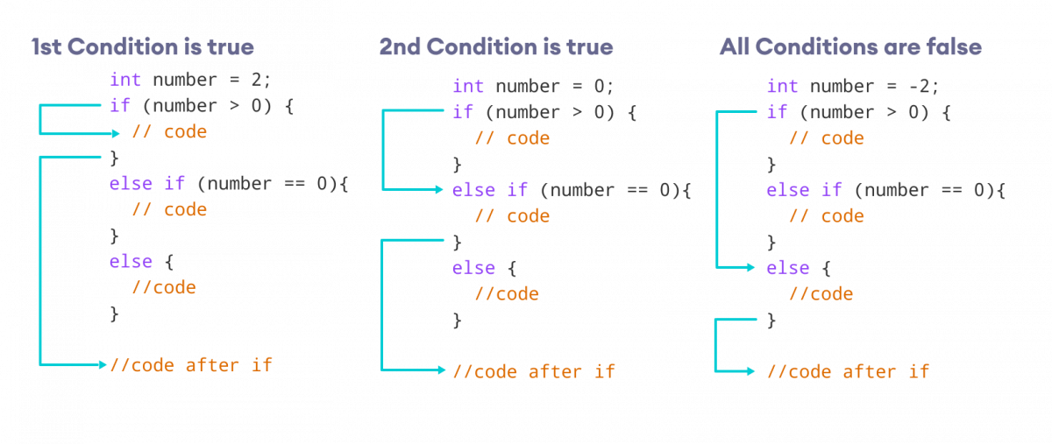Working of if...else...if ladder

Example 4: Java if...else...if Statement
class Main {
public static void main(String[] args) {

int number = 0;

// checks if number is greater than 0
if (number > 0) {
System.out.println("The number is positive.");
}

// checks if number is less than 0
else if (number < 0) {
System.out.println("The number is negative.");
}

// if both condition is false
else {
System.out.println("The number is 0.");
}
}
}
Output
The number is 0.
In the above example, we are checking whether number is positive, negative, or zero. Here, we have two condition expressions:
- number > 0 - checks if number is greater than 0
- number < 0 - checks if number is less than 0
Here, the value of number is 0. So both the conditions evaluate to false. Hence the statement inside the body of else is executed.
Java provides a special operator called ternary operator, which is a kind of shorthand notation of if...else...if statement.

4. Java Nested if..else Statement
In Java, it is also possible to use if..else statements inside an if...else statement. It's called the nested if...else statement.
Here's a program to find the largest of 3 numbers using the nested if...else statement.

Example 5: Nested if...else Statement
class Main {
public static void main(String[] args) {

// declaring double type variables
Double n1 = -1.0, n2 = 4.5, n3 = -5.3, largest;

// checks if n1 is greater than or equal to n2
if (n1 >= n2) {

// if...else statement inside the if block
// checks if n1 is greater than or equal to n3
if (n1 >= n3) {
largest = n1;
}

else {
largest = n3;
}
} else {

// if..else statement inside else block
// checks if n2 is greater than or equal to n3
if (n2 >= n3) {
largest = n2;
}

else {
largest = n3;
}
}

System.out.println("Largest Number: " + largest);
}
}
Output:
Largest Number: 4.5
In the above programs, we have assigned the value of variables ourselves to make this easier.
However, in real-world applications, these values may come from user input data, log files, form submission, etc.

Java switch Statement
The switch statement allows us to execute a block of code among many alternatives.
The syntax of the switch statement in Java is:
switch (expression) {

case value1:
// code
break;

case value2:
// code
break;

...
...

default:
// default statements
}
How does the switch-case statement work?
The expression is evaluated once and compared with the values of each case.
- If expression matches with value1, the code of case value1 are executed. Similarly, the code of case value2 is executed if expression matches with value2.
- If there is no match, the code of the default case is executed.
The working of the switch-case statement is similar to the Java if...else...if ladder. However, the syntax of the switch statement is cleaner and much easier to read and write.

Example: Java switch Statement
// Java Program to check the size
// using the switch...case statement

class Main {
public static void main(String[] args) {

int number = 44;
String size;

// switch statement to check size
switch (number) {

case 29:
size = "Small";
break;

case 42:
size = "Medium";
break;

// match the value of week
case 44:
size = "Large";
break;

case 48:
size = "Extra Large";
break;

default:
size = "Unknown";
break;

}
System.out.println("Size: " + size);
}
}
Output:
Size: Large
In the above example, we have used the switch statement to find the size. Here, we have a variable number. The variable is compared with the value of each case statement.
Since the value matches with 44, the code of case 44 is executed.
size = "Large";
break;
Here, the size variable is assigned with the value Large.

Flowchart of switch Statement
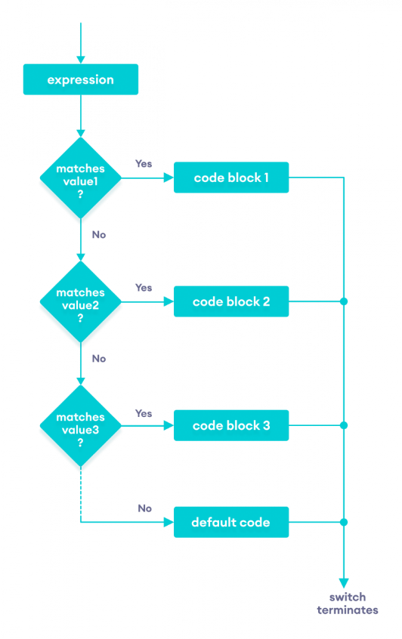
Flow chart of the Java switch statement

break statement in Java switch...case
Notice that we have been using break in each case block.
...
case 29:
size = "Small";
break;
...
The break statement is used to terminate the switch-case statement. If break is not used, all the cases after the matching case are also executed. For example,
class Main {
public static void main(String[] args) {

int expression = 2;

// switch statement to check size
switch (expression) {
case 1:
System.out.println("Case 1");

// matching case
case 2:
System.out.println("Case 2");

case 3:
System.out.println("Case 3");

default:
System.out.println("Default case");
}
}
}
Output
Case 2
Case 3
Default case
In the above example, expression matches with case 2. Here, we haven't used the break statement after each case.
Hence, all the cases after case 2 are also executed.
This is why the break statement is needed to terminate the switch-case statement after the matching case

default case in Java switch-case
The switch statement also includes an optional default case. It is executed when the expression doesn't match any of the cases. For example,
class Main {
public static void main(String[] args) {

int expression = 9;

switch(expression) {

case 2:
System.out.println("Small Size");
break;

case 3:
System.out.println("Large Size");
break;

// default case
default:
System.out.println("Unknown Size");
}
}
}
Output
Unknown Size
In the above example, we have created a switch-case statement. Here, the value of expression doesn't match with any of the cases.
Hence, the code inside the default case is executed.
default:
System.out.println("Unknown Size);
The Java switch statement only works with:
- Primitive data types: byte, short, char, and int
- Enumerated types
- String Class
- Wrapper Classes: Character, Byte, Short, and Integer.

Java for Loop
In computer programming, loops are used to repeat a block of code. For example, if you want to show a message 100 times, then rather than typing the same code 100 times, you can use a loop.
In Java, there are three types of loops.
- for loop
- while loop
- do...while loop

Java for Loop
Java for loop is used to run a block of code for a certain number of times. The syntax of for loop is:
for (initialExpression; testExpression; updateExpression) {
// body of the loop
}
Here,
- The initialExpression initializes and/or declares variables and executes only once.
- The condition is evaluated. If the condition is true, the body of the for loop is executed.
- The updateExpression updates the value of initialExpression.
- The condition is evaluated again. The process continues until the condition is false.
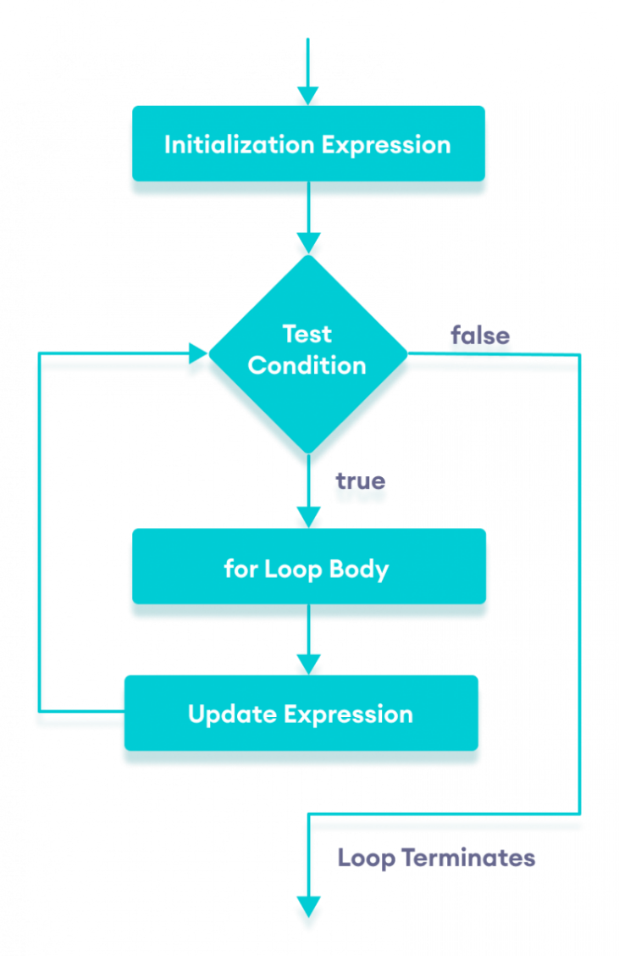
Flowchart of Java for loop

Example 1: Display a Text Five Times
// Program to print a text 5 times

class Main {
public static void main(String[] args) {

int n = 5;
// for loop
for (int i = 1; i <= n; ++i) {
System.out.println("Java is fun");
}
}
}
Output
Java is fun
Java is fun
Java is fun
Java is fun
Java is fun
Here is how this program works.
Iteration | Variable | Condition: i <= n | Action
1st | i = 1  n = 5 | true | Java is fun is printed.  i is increased to 2.
2nd | i = 2  n = 5 | true | Java is fun is printed.  i is increased to 3.
3rd | i = 3  n = 5 | true | Java is fun is printed.  i is increased to 4.
4th | i = 4  n = 5 | true | Java is fun is printed.  i is increased to 5.
5th | i = 5  n = 5 | true | Java is fun is printed.  i is increased to 6.
6th | i = 6  n = 5 | false | The loop is terminated.

Example 2: Display numbers from 1 to 5
// Program to print numbers from 1 to 5

class Main {
public static void main(String[] args) {

int n = 5;
// for loop
for (int i = 1; i <= n; ++i) {
System.out.println(i);
}
}
}
Output
1
2
3
4
5
Here is how the program works.
Iteration | Variable | Condition: i <= n | Action
1st | i = 1  n = 5 | true | 1 is printed.  i is increased to 2.
2nd | i = 2  n = 5 | true | 2 is printed.  i is increased to 3.
3rd | i = 3  n = 5 | true | 3 is printed.  i is increased to 4.
4th | i = 4  n = 5 | true | 4 is printed.  i is increased to 5.
5th | i = 5  n = 5 | true | 5 is printed.  i is increased to 6.
6th | i = 6  n = 5 | false | The loop is terminated.

Example 3: Display Sum of n Natural Numbers
// Program to find the sum of natural numbers from 1 to 1000.

class Main {
public static void main(String[] args) {

int sum = 0;
int n = 1000;

// for loop
for (int i = 1; i <= n; ++i) {
// body inside for loop
sum += i; // sum = sum + i
}

System.out.println("Sum = " + sum);
}
}
Output:
Sum = 500500
Here, the value of sum is 0 initially. Then, the for loop is iterated from i = 1 to 1000. In each iteration, iis added to sum and its value is increased by 1.
When i becomes 1001, the test condition is false and sum will be equal to 0 + 1 + 2 + .... + 1000.
The above program to add the sum of natural numbers can also be written as
// Program to find the sum of natural numbers from 1 to 1000.

class Main {
public static void main(String[] args) {

int sum = 0;
int n = 1000;

// for loop
for (int i = n; i >= 1; --i) {
// body inside for loop
sum += i; // sum = sum + i
}

System.out.println("Sum = " + sum);
}
}
The output of this program is the same as the Example 3.

Java for-each Loop
The Java for loop has an alternative syntax that makes it easy to iterate through arrays and collections. For example,
// print array elements

class Main {
public static void main(String[] args) {

// create an array
int[] numbers = {3, 7, 5, -5};

// iterating through the array
for (int number: numbers) {
System.out.println(number);
}
}
}
Output
3
7
5
-5
Here, we have used the for-each loop to print each element of the numbers array one by one.
In the first iteration of the loop, number will be 3, number will be 7 in second iteration and so on.

Java Infinite for Loop
If we set the test expression in such a way that it never evaluates to false, the for loop will run forever. This is called infinite for loop. For example,
// Infinite for Loop

class Infinite {
public static void main(String[] args) {

int sum = 0;

for (int i = 1; i <= 10; --i) {
System.out.println("Hello");
}
}
}
Here, the test expression ,i <= 10, is never false and Hello is printed repeatedly until the memory runs out.

Java for-each Loop
In Java, the for-each loop is used to iterate through elements of arrays and collections (like ArrayList). It is also known as the enhanced for loop.

for-each Loop Sytnax
The syntax of the Java for-each loop is:
for(dataType item : array) {
...
}
Here,
- array - an array or a collection
- item - each item of array/collection is assigned to this variable
- dataType - the data type of the array/collection

Example 1: Print Array Elements
// print array elements

class Main {
public static void main(String[] args) {

// create an array
int[] numbers = {3, 9, 5, -5};

// for each loop
for (int number: numbers) {
System.out.println(number);
}
}
}
Output
3
9
5
-5
Here, we have used the for-each loop to print each element of the numbers array one by one.
- In the first iteration, item will be 3.
- In the second iteration, item will be 9.
- In the third iteration, item will be 5.
- In the fourth iteration, item will be -5.

Example 2: Sum of Array Elements
// Calculate the sum of all elements of an array

class Main {
public static void main(String[] args) {

// an array of numbers
int[] numbers = {3, 4, 5, -5, 0, 12};
int sum = 0;

// iterating through each element of the array
for (int number: numbers) {
sum += number;
}

System.out.println("Sum = " + sum);
}
}
Output:
Sum = 19
In the above program, the execution of the for each loop looks as:
Iteration | Variables
1 | number = 3  sum = 0 + 3 = 3
2 | number = 4  sum = 3 + 4 = 7
3 | number = 5  sum = 7 + 5 = 12
4 | number = -5  sum = 12 + (-5) = 7
5 | number = 0  sum = 7 + 0 = 7
6 | number = 12  sum = 7 + 12 = 19
As we can see, we have added each element of the numbers array to the sum variable in each iteration of the loop.

for loop Vs for-each loop
Let's see how a for-each loop is different from a regular Java for loop.

1. Using for loop
class Main {
public static void main(String[] args) {

char[] vowels = {'a', 'e', 'i', 'o', 'u'};

// iterating through an array using a for loop
for (int i = 0; i < vowels.length; ++ i) {
System.out.println(vowels[i]);
}
}
}
Output:
a
e
i
o
u

2. Using for-each Loop
class Main {
public static void main(String[] args) {

char[] vowels = {'a', 'e', 'i', 'o', 'u'};

// iterating through an array using the for-each loop
for (char item: vowels) {
System.out.println(item);
}
}
}
Output:
a
e
i
o
u
Here, the output of both programs is the same. However, the for-each loop is easier to write and understand.
This is why the for-each loop is preferred over the for loop when working with arrays and collections.

Java while and do...while Loop
In computer programming, loops are used to repeat a block of code. For example, if you want to show a message 100 times, then you can use a loop. It's just a simple example; you can achieve much more with loops.

Java while loop
Java while loop is used to run a specific code until a certain condition is met. The syntax of the while loop is:
while (testExpression) {
// body of loop
}
Here,
- A while loop evaluates the textExpression inside the parenthesis ().
- If the textExpression evaluates to true, the code inside the while loop is executed.
- The textExpression is evaluated again.
- This process continues until the textExpression is false.
- When the textExpression evaluates to false, the loop stops.

Flowchart of while loop
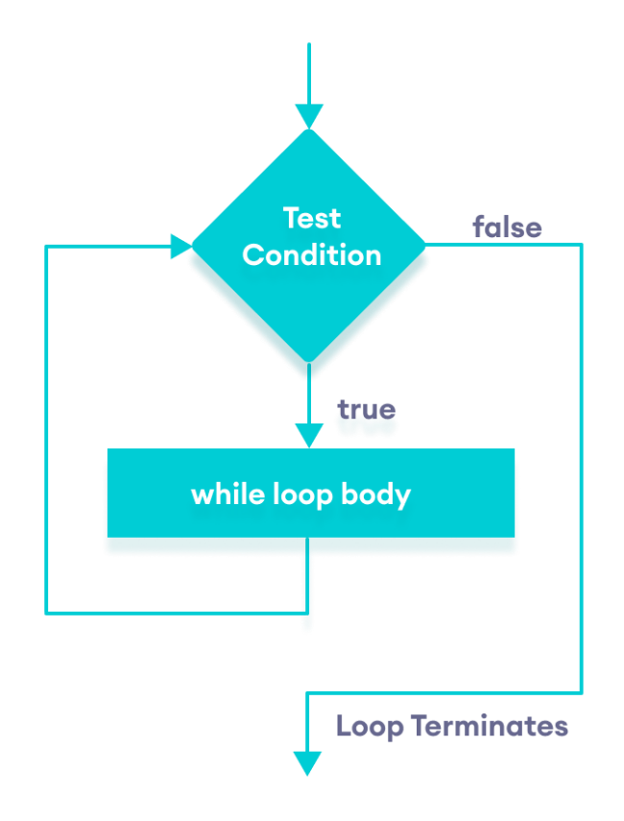
Flowchart of Java while loop

Example 1: Display Numbers from 1 to 5
// Program to display numbers from 1 to 5

class Main {
public static void main(String[] args) {

// declare variables
int i = 1, n = 5;

// while loop from 1 to 5
while(i <= n) {
System.out.println(i);
i++;
}
}
}
Output
1
2
3
4
5
Here is how this program works.
Iteration | Variable | Condition: i <= n | Action
1st | i = 1  n = 5 | true | 1 is printed.  i is increased to 2.
2nd | i = 2  n = 5 | true | 2 is printed.  i is increased to 3.
3rd | i = 3  n = 5 | true | 3 is printed.  i is increased to 4.
4th | i = 4  n = 5 | true | 4 is printed.  i is increased to 5.
5th | i = 5  n = 5 | true | 5 is printed.  i is increased to 6.
6th | i = 6  n = 5 | false | The loop is terminated

Example 2: Sum of Positive Numbers Only
// Java program to find the sum of positive numbers
import java.util.Scanner;

class Main {
public static void main(String[] args) {

int sum = 0;

// create an object of Scanner class
Scanner input = new Scanner(System.in);

// take integer input from the user
System.out.println("Enter a number");
int number = input.nextInt();

// while loop continues
// until entered number is positive
while (number >= 0) {
// add only positive numbers
sum += number;

System.out.println("Enter a number");
number = input.nextInt();
}

System.out.println("Sum = " + sum);
input.close();
}
}
Output
Enter a number
25
Enter a number
9
Enter a number
5
Enter a number
-3
Sum = 39
In the above program, we have used the Scanner class to take input from the user. Here, nextInt() takes integer input from the user.
The while loop continues until the user enters a negative number. During each iteration, the number entered by the user is added to the sum variable.
When the user enters a negative number, the loop terminates. Finally, the total sum is displayed.

Java do...while loop
The do...while loop is similar to while loop. However, the body of do...while loop is executed once before the test expression is checked. For example,
do {
// body of loop
} while(textExpression)
Here,
- The body of the loop is executed at first. Then the textExpression is evaluated.
- If the textExpression evaluates to true, the body of the loop inside the do statement is executed again.
- The textExpression is evaluated once again.
- If the textExpression evaluates to true, the body of the loop inside the do statement is executed again.
- This process continues until the textExpression evaluates to false. Then the loop stops.

Flowchart of do...while loop
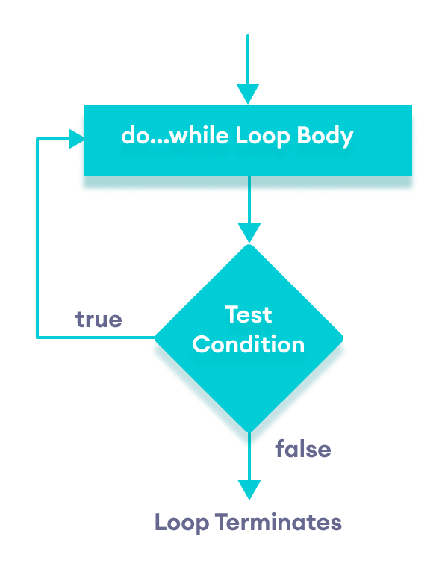
Flowchart of Java do while loop
Let's see the working of do...while loop.

Example 3: Display Numbers from 1 to 5
// Java Program to display numbers from 1 to 5

import java.util.Scanner;

// Program to find the sum of natural numbers from 1 to 100.

class Main {
public static void main(String[] args) {

int i = 1, n = 5;

// do...while loop from 1 to 5
do {
System.out.println(i);
i++;
} while(i <= n);
}
}
Output
1
2
3
4
5
Here is how this program works.
Iteration | Variable | Condition: i <= n | Action
 | i = 1  n = 5 | not checked | 1 is printed.  i is increased to 2.
1st | i = 2  n = 5 | true | 2 is printed.  i is increased to 3.
2nd | i = 3  n = 5 | true | 3 is printed.  i is increased to 4.
3rd | i = 4  n = 5 | true | 4 is printed.  i is increased to 5.
4th | i = 5  n = 5 | true | 6 is printed.  i is increased to 6.
5th | i = 6  n = 5 | false | The loop is terminated

Example 4: Sum of Positive Numbers
// Java program to find the sum of positive numbers
import java.util.Scanner;

class Main {
public static void main(String[] args) {

int sum = 0;
int number = 0;

// create an object of Scanner class
Scanner input = new Scanner(System.in);

// do...while loop continues
// until entered number is positive
do {
// add only positive numbers
sum += number;
System.out.println("Enter a number");
number = input.nextInt();
} while(number >= 0);

System.out.println("Sum = " + sum);
input.close();
}
}
Output 1
Enter a number
25
Enter a number
9
Enter a number
5
Enter a number
-3
Sum = 39
Here, the user enters a positive number, that number is added to the sum variable. And this process continues until the number is negative. When the number is negative, the loop terminates and displays the sum without adding the negative number.
Output 2
Enter a number
-8
Sum is 0
Here, the user enters a negative number. The test condition will be false but the code inside of the loop executes once.

Infinite while loop
If the condition of a loop is always true, the loop runs for infinite times (until the memory is full). For example,
// infinite while loop
while(true){
// body of loop
}
Here is an example of an infinite do...while loop.
// infinite do...while loop
int count = 1;
do {
// body of loop
} while(count == 1)
In the above programs, the textExpression is always true. Hence, the loop body will run for infinite times.

for and while loops
The for loop is used when the number of iterations is known. For example,
for (let i = 1; i <=5; ++i) {
// body of loop
}
And while and do...while loops are generally used when the number of iterations is unknown. For example,
while (condition) {
// body of loop
}

Java break Statement
While working with loops, it is sometimes desirable to skip some statements inside the loop or terminate the loop immediately without checking the test expression.
In such cases, break and continue statements are used.
The break statement in Java terminates the loop immediately, and the control of the program moves to the next statement following the loop.
It is almost always used with decision-making statements (Java if...else Statement).
Here is the syntax of the break statement in Java:
break;

How break statement works?
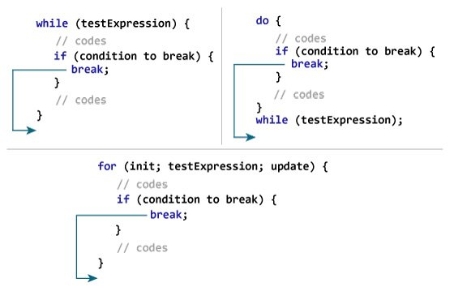
Working of Java break Statement

Example 1: Java break statement
class Test {
public static void main(String[] args) {

// for loop
for (int i = 1; i <= 10; ++i) {

// if the value of i is 5 the loop terminates
if (i == 5) {
break;
}
System.out.println(i);
}
}
}
Output:
1
2
3
4
In the above program, we are using the for loop to print the value of i in each iteration.
if (i == 5) {
break;
}
This means when the value of i is equal to 5, the loop terminates. Hence we get the output with values less than 5 only.

Example 2: Java break statement
The program below calculates the sum of numbers entered by the user until user enters a negative number.
To take input from the user, we have used the Scanner object.
import java.util.Scanner;

class UserInputSum {
public static void main(String[] args) {

Double number, sum = 0.0;

// create an object of Scanner
Scanner input = new Scanner(System.in);

while (true) {
System.out.print("Enter a number: ");

// takes double input from user
number = input.nextDouble();

// if number is negative the loop terminates
if (number < 0.0) {
break;
}

sum += number;
}
System.out.println("Sum = " + sum);
}
}
Output:
Enter a number: 3.2
Enter a number: 5
Enter a number: 2.3
Enter a number: 0
Enter a number: -4.5
Sum = 10.5
In the above program, the test expression of the while loop is always true. Here, notice the line,
if (number < 0.0) {
break;
}
This means when the user input negative numbers, the while loop is terminated.

Java break and Nested Loop
In the case of nested loops, the break statement terminates the innermost loop.
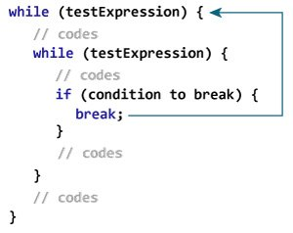
Working of break Statement with Nested Loops
Here, the break statement terminates the innermost while loop, and control jumps to the outer loop.

Labeled break Statement
Till now, we have used the unlabeled break statement. It terminates the innermost loop and switch statement. However, there is another form of break statement in Java known as the labeled break.
We can use the labeled break statement to terminate the outermost loop as well.
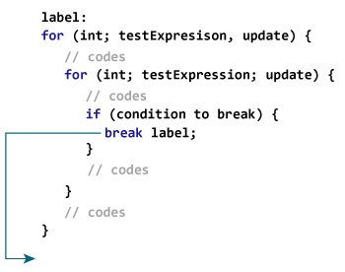
Working of the labeled break statement in Java
As you can see in the above image, we have used the label identifier to specify the outer loop. Now, notice how the break statement is used (break label;).
Here, the break statement is terminating the labeled statement (i.e. outer loop). Then, the control of the program jumps to the statement after the labeled statement.
Here's another example:
while (testExpression) {
// codes
second:
while (testExpression) {
// codes
while(testExpression) {
// codes
break second;
}
}
// control jumps here
}
In the above example, when the statement break second; is executed, the while loop labeled as second is terminated. And, the control of the program moves to the statement after the second while loop.

Example 3: labeled break Statement
class LabeledBreak {
public static void main(String[] args) {

// the for loop is labeled as first
first:
for( int i = 1; i < 5; i++) {

// the for loop is labeled as second
second:
for(int j = 1; j < 3; j ++ ) {
System.out.println("i = " + i + "; j = " +j);

// the break statement breaks the first for loop
if ( i == 2)
break first;
}
}
}
}
Output:
i = 1; j = 1
i = 1; j = 2
i = 2; j = 1
In the above example, the labeled break statement is used to terminate the loop labeled as first. That is,
first:
for(int i = 1; i < 5; i++) {...}
Here, if we change the statement break first; to break second; the program will behave differently. In this case, for loop labeled as second will be terminated. For example,
class LabeledBreak {
public static void main(String[] args) {

// the for loop is labeled as first
first:
for( int i = 1; i < 5; i++) {

// the for loop is labeled as second
second:
for(int j = 1; j < 3; j ++ ) {

System.out.println("i = " + i + "; j = " +j);

// the break statement terminates the loop labeled as second
if ( i == 2)
break second;
}
}
}
}
Output:
i = 1; j = 1
i = 1; j = 2
i = 2; j = 1
i = 3; j = 1
i = 3; j = 2
i = 4; j = 1
i = 4; j = 2
The break statement is also used to terminate cases inside the switch statement.

Java continue Statement
While working with loops, sometimes you might want to skip some statements or terminate the loop. In such cases, break and continue statements are used.

Java continue
The continue statement skips the current iteration of a loop (for, while, do...while, etc).
After the continue statement, the program moves to the end of the loop. And, test expression is evaluated (update statement is evaluated in case of the for loop).
Here's the syntax of the continue statement.
continue;
The continue statement is almost always used in decision-making statements (if...else Statement).

Working of Java continue statement
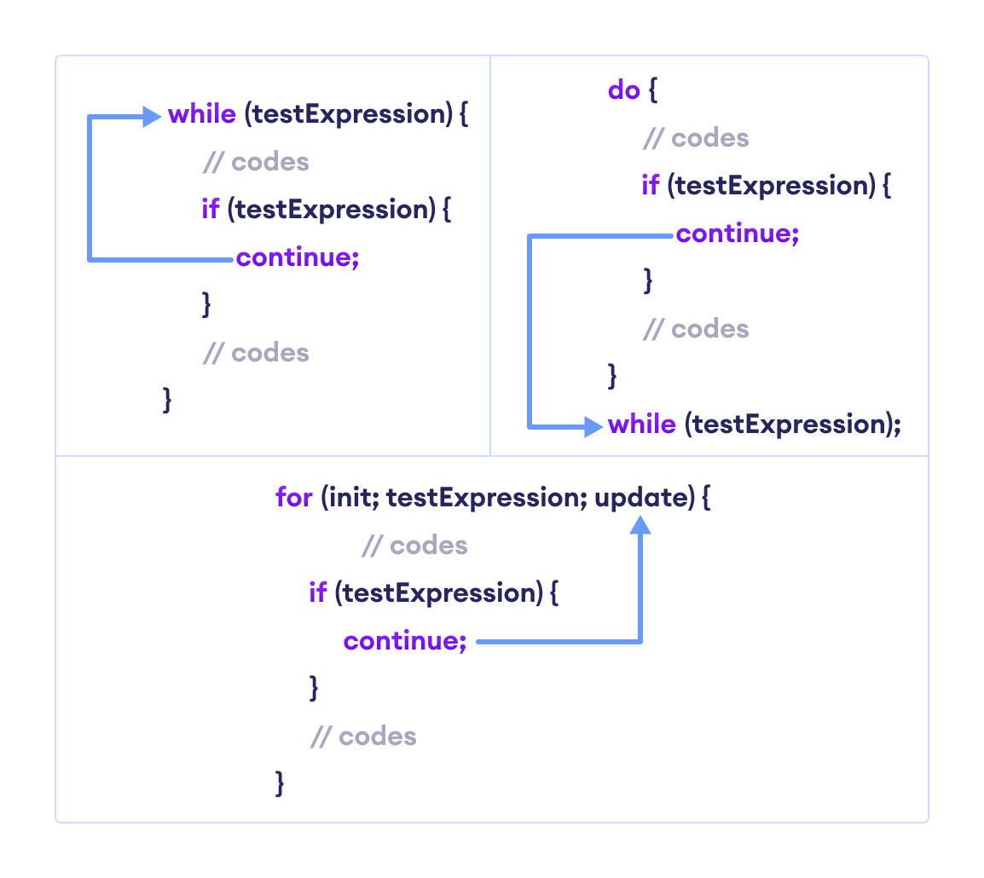Working of Java continue Statement

Example 1: Java continue statement
class Main {
public static void main(String[] args) {

// for loop
for (int i = 1; i <= 10; ++i) {

// if value of i is between 4 and 9
// continue is executed
if (i > 4 && i < 9) {
continue;
}
System.out.println(i);
}
}
}
Output:
1
2
3
4
9
10
In the above program, we are using the for loop to print the value of i in each iteration.
if (i > 4 && i < 9) {
continue;
}
Here, the continue statement is executed when the value of i becomes more than 4 and less than 9.
It then skips the print statement for those values. Hence, the output skips the values 5, 6, 7, and 8.

Example 2: Compute the sum of 5 positive numbers
import java.util.Scanner;

class Main {
public static void main(String[] args) {

Double number, sum = 0.0;
// create an object of Scanner
Scanner input = new Scanner(System.in);

for (int i = 1; i < 6; ++i) {
System.out.print("Enter number " + i + " : ");
// takes input from the user
number = input.nextDouble();

// if number is negative
// continue statement is executed
if (number <= 0.0) {
continue;
}

sum += number;
}
System.out.println("Sum = " + sum);
input.close();
}
}
Output:
Enter number 1: 2.2
Enter number 2: 5.6
Enter number 3: 0
Enter number 4: -2.4
Enter number 5: -3
Sum = 7.8
In the above example, we have used the for loop to print the sum of 5 positive numbers. Notice the line,
if (number < 0.0) {
continue;
}
Here, when the user enters a negative number, the continue statement is executed. This skips the current iteration of the loop and takes the program control to the update expression of the loop.
To take input from the user, we have used the Scanner object.

Java continue with Nested Loop
In the case of nested loops in Java, the continue statement skips the current iteration of the innermost loop.
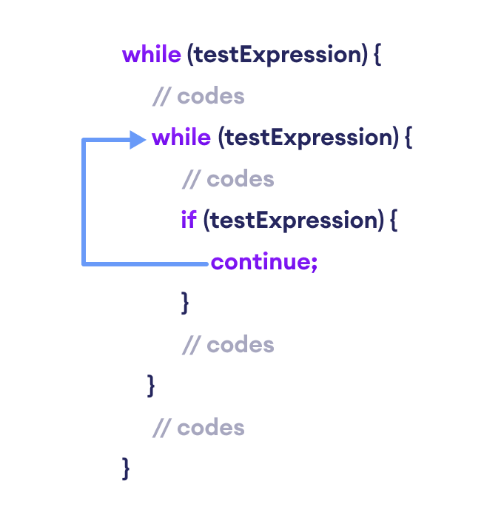
Working of Java continue statement with Nested Loops

Example 3: continue with Nested Loop
class Main {
public static void main(String[] args) {

int i = 1, j = 1;

// outer loop
while (i <= 3) {

System.out.println("Outer Loop: " + i);

// inner loop
while(j <= 3) {

if(j == 2) {
j++;
continue;
}

System.out.println("Inner Loop: " + j);
j++;
}
i++;
}
}
}
Output
Outer Loop: 1
Inner Loop: 1
Inner Loop: 3
Outer Loop: 2
Outer Loop: 3
In the above example, we have used the nested while loop. Note that we have used the continue statement inside the inner loop.
if(j == 2) {
j++;
continue:
}
Here, when the value of j is 2, the value of j is increased and the continue statement is executed.
This skips the iteration of the inner loop. Hence, the text Inner Loop: 2 is skipped from the output.

Labeled continue Statement
Till now, we have used the unlabeled continue statement. However, there is another form of continue statement in Java known as labeled continue.
It includes the label of the loop along with the continue keyword. For example,
continue label;
Here, the continue statement skips the current iteration of the loop specified by label.
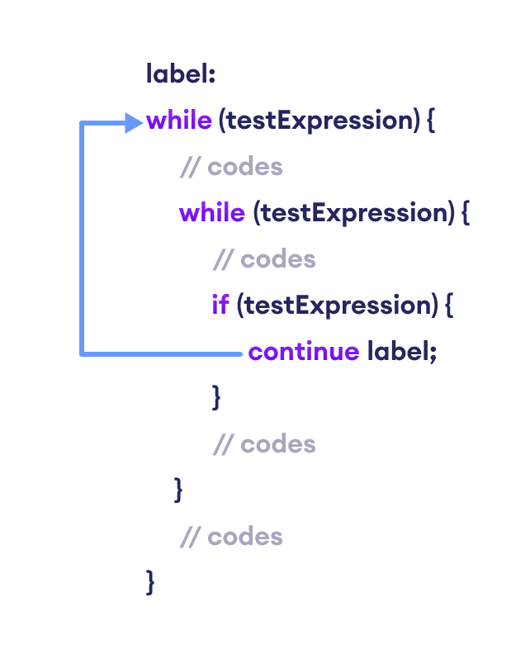
Working of the Java labeled continue Statement
We can see that the label identifier specifies the outer loop. Notice the use of the continue inside the inner loop.
Here, the continue statement is skipping the current iteration of the labeled statement (i.e. outer loop). Then, the program control goes to the next iteration of the labeled statement.

Example 4: labeled continue Statement
class Main {
public static void main(String[] args) {

// outer loop is labeled as first
first:
for (int i = 1; i < 6; ++i) {

// inner loop
for (int j = 1; j < 5; ++j) {
if (i == 3 || j == 2)

// skips the current iteration of outer loop
continue first;
System.out.println("i = " + i + "; j = " + j);
}
}
}
}
Output:
i = 1; j = 1
i = 2; j = 1
i = 4; j = 1
i = 5; j = 1
In the above example, the labeled continue statement is used to skip the current iteration of the loop labeled as first.
if (i==3 || j==2)
continue first;
Here, we can see the outermost for loop is labeled as first,
first:
for (int i = 1; i < 6; ++i) {..}
Hence, the iteration of the outer for loop is skipped if the value of i is 3 or the value of j is 2.
The use of labeled continue is often discouraged as it makes your code hard to understand. If you are in a situation where you have to use labeled continue, refactor your code and try to solve it in a different way to make it more readable.

Java Arrays
An array is a collection of similar types of data.
For example, if we want to store the names of 100 people then we can create an array of the string type that can store 100 names.
String[] array = new String[100];
Here, the above array cannot store more than 100 names. The number of values in a Java array is always fixed.

How to declare an array in Java?
In Java, here is how we can declare an array.
dataType[] arrayName;
- dataType - it can be primitive data types like int, char, double, byte, etc. or Java objects
- arrayName - it is an identifier
For example,
double[] data;
Here, data is an array that can hold values of type double.
But, how many elements can array this hold?
To define the number of elements that an array can hold, we have to allocate memory for the array in Java. For example,
// declare an array
double[] data;

// allocate memory
data = new double[10];
Here, the array can store 10 elements. We can also say that the size or length of the array is 10.
In Java, we can declare and allocate the memory of an array in one single statement. For example,
double[] data = new double[10];

How to Initialize Arrays in Java?
In Java, we can initialize arrays during declaration. For example,
//declare and initialize and array
int[] age = {12, 4, 5, 2, 5};
Here, we have created an array named age and initialized it with the values inside the curly brackets.
Note that we have not provided the size of the array. In this case, the Java compiler automatically specifies the size by counting the number of elements in the array (i.e. 5).
In the Java array, each memory location is associated with a number. The number is known as an array index. We can also initialize arrays in Java, using the index number. For example,
// declare an array
int[] age = new int[5];

// initialize array
age[0] = 12;
age[1] = 4;
age[2] = 5;
..
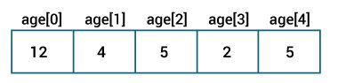
Java Arrays initialization
Note:
- Array indices always start from 0. That is, the first element of an array is at index 0.
- If the size of an array is n, then the last element of the array will be at index n-1.

How to Access Elements of an Array in Java?
We can access the element of an array using the index number. Here is the syntax for accessing elements of an array,
// access array elements
array[index]
Let's see an example of accessing array elements using index numbers.

Example: Access Array Elements
class Main {
public static void main(String[] args) {

// create an array
int[] age = {12, 4, 5, 2, 5};

// access each array elements
System.out.println("Accessing Elements of Array:");
System.out.println("First Element: " + age[0]);
System.out.println("Second Element: " + age[1]);
System.out.println("Third Element: " + age[2]);
System.out.println("Fourth Element: " + age[3]);
System.out.println("Fifth Element: " + age[4]);
}
}
Output
Accessing Elements of Array:
First Element: 12
Second Element: 4
Third Element: 5
Fourth Element: 2
Fifth Element: 5
In the above example, notice that we are using the index number to access each element of the array.
We can use loops to access all the elements of the array at once.

Looping Through Array Elements
In Java, we can also loop through each element of the array. For example,

Example: Using For Loop
class Main {
public static void main(String[] args) {

// create an array
int[] age = {12, 4, 5};

// loop through the array
// using for loop
System.out.println("Using for Loop:");
for(int i = 0; i < age.length; i++) {
System.out.println(age[i]);
}
}
}
Output
Using for Loop:
12
4
5
In the above example, we are using the for Loop in Java to iterate through each element of the array. Notice the expression inside the loop,
age.length
Here, we are using the length property of the array to get the size of the array.
We can also use the for-each loop to iterate through the elements of an array. For example,

Example: Using the for-each Loop
class Main {
public static void main(String[] args) {

// create an array
int[] age = {12, 4, 5};

// loop through the array
// using for loop
System.out.println("Using for-each Loop:");
for(int a : age) {
System.out.println(a);
}
}
}
Output
Using for-each Loop:
12
4
5

Example: Compute Sum and Average of Array Elements
class Main {
public static void main(String[] args) {

int[] numbers = {2, -9, 0, 5, 12, -25, 22, 9, 8, 12};
int sum = 0;
Double average;

// access all elements using for each loop
// add each element in sum
for (int number: numbers) {
sum += number;
}

// get the total number of elements
int arrayLength = numbers.length;

// calculate the average
// convert the average from int to double
average = ((double)sum / (double)arrayLength);

System.out.println("Sum = " + sum);
System.out.println("Average = " + average);
}
}
Output:
Sum = 36
Average = 3.6
In the above example, we have created an array of named numbers. We have used the for...each loop to access each element of the array.
Inside the loop, we are calculating the sum of each element. Notice the line,
int arrayLength = number.length;
Here, we are using the length attribute of the array to calculate the size of the array. We then calculate the average using:
average = ((double)sum / (double)arrayLength);
As you can see, we are converting the int value into double. This is called type casting in Java.

Multidimensional Arrays
Arrays we have mentioned till now are called one-dimensional arrays. However, we can declare multidimensional arrays in Java.
A multidimensional array is an array of arrays. That is, each element of a multidimensional array is an array itself. For example,
double[][] matrix = {{1.2, 4.3, 4.0},
{4.1, -1.1}
};
Here, we have created a multidimensional array named matrix. It is a 2-dimensional array.

Java Multidimensional Arrays
A multidimensional array is an array of arrays. Each element of a multidimensional array is an array itself. For example,
int[][] a = new int[3][4];
Here, we have created a multidimensional array named a. It is a 2-dimensional array, that can hold a maximum of 12 elements,
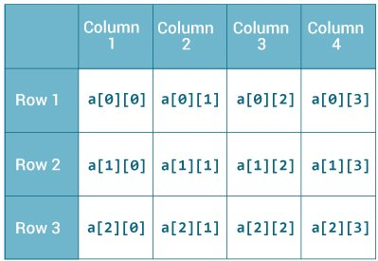
2-dimensional Array
Remember, Java uses zero-based indexing, that is, indexing of arrays in Java starts with 0 and not 1.
Let's take another example of the multidimensional array. This time we will be creating a 3-dimensional array. For example,
String[][][] data = new String[3][4][2];
Here, data is a 3d array that can hold a maximum of 24 (3*4*2) elements of type String.

How to initialize a 2d array in Java?
Here is how we can initialize a 2-dimensional array in Java.
int[][] a = {
{1, 2, 3},
{4, 5, 6, 9},
{7},
};
As we can see, each element of the multidimensional array is an array itself. And also, unlike C/C++, each row of the multidimensional array in Java can be of different lengths.
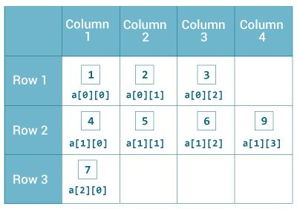
Initialization of 2-dimensional Array

Example: 2-dimensional Array
class MultidimensionalArray {
public static void main(String[] args) {

// create a 2d array
int[][] a = {
{1, 2, 3},
{4, 5, 6, 9},
{7},
};

// calculate the length of each row
System.out.println("Length of row 1: " + a[0].length);
System.out.println("Length of row 2: " + a[1].length);
System.out.println("Length of row 3: " + a[2].length);
}
}
Output:
Length of row 1: 3
Length of row 2: 4
Length of row 3: 1
In the above example, we are creating a multidimensional array named a. Since each component of a multidimensional array is also an array (a[0], a[1] and a[2] are also arrays).
Here, we are using the length attribute to calculate the length of each row.

Example: Print all elements of 2d array Using Loop
class MultidimensionalArray {
public static void main(String[] args) {

int[][] a = {
{1, -2, 3},
{-4, -5, 6, 9},
{7},
};

for (int i = 0; i < a.length; ++i) {
for(int j = 0; j < a[i].length; ++j) {
System.out.println(a[i][j]);
}
}
}
}
Output:
1
-2
3
-4
-5
6
9
7
We can also use the for...each loop to access elements of the multidimensional array. For example,
class MultidimensionalArray {
public static void main(String[] args) {

// create a 2d array
int[][] a = {
{1, -2, 3},
{-4, -5, 6, 9},
{7},
};

// first for...each loop access the individual array
// inside the 2d array
for (int[] innerArray: a) {
// second for...each loop access each element inside the row
for(int data: innerArray) {
System.out.println(data);
}
}
}
}
Output:
1
-2
3
-4
-5
6
9
7
In the above example, we are have created a 2d array named a. We then used for loop and for...each loop to access each element of the array.

How to initialize a 3d array in Java?
Let's see how we can use a 3d array in Java. We can initialize a 3d array similar to the 2d array. For example,
// test is a 3d array
int[][][] test = {
{
{1, -2, 3},
{2, 3, 4}
},
{
{-4, -5, 6, 9},
{1},
{2, 3}
}
};
Basically, a 3d array is an array of 2d arrays. The rows of a 3d array can also vary in length just like in a 2d array.

Example: 3-dimensional Array
class ThreeArray {
public static void main(String[] args) {

// create a 3d array
int[][][] test = {
{
{1, -2, 3},
{2, 3, 4}
},
{
{-4, -5, 6, 9},
{1},
{2, 3}
}
};

// for..each loop to iterate through elements of 3d array
for (int[][] array2D: test) {
for (int[] array1D: array2D) {
for(int item: array1D) {
System.out.println(item);
}
}
}
}
}
Output:
1
-2
3
2
3
4
-4
-5
6
9
1
2
3
.Java Copy Arrays
In Java, we can copy one array into another. There are several techniques you can use to copy arrays in Java.

1. Copying Arrays Using Assignment Operator
Let's take an example,
class Main {
public static void main(String[] args) {

int [] numbers = {1, 2, 3, 4, 5, 6};
int [] positiveNumbers = numbers; // copying arrays

for (int number: positiveNumbers) {
System.out.print(number + ", ");
}
}
}
Output:
1, 2, 3, 4, 5, 6
In the above example, we have used the assignment operator (=) to copy an array named numbers to another array named positiveNumbers.
This technique is the easiest one and it works as well. However, there is a problem with this technique. If we change elements of one array, corresponding elements of the other arrays also change. For example,
class Main {
public static void main(String[] args) {

int [] numbers = {1, 2, 3, 4, 5, 6};
int [] positiveNumbers = numbers; // copying arrays

// change value of first array
numbers[0] = -1;

// printing the second array
for (int number: positiveNumbers) {
System.out.print(number + ", ");
}
}
}
Output:
-1, 2, 3, 4, 5, 6
Here, we can see that we have changed one value of the numbers array. When we print the positiveNumbers array, we can see that the same value is also changed.
It's because both arrays refer to the same array object. This is because of the shallow copy.
Now, to make new array objects while copying the arrays, we need deep copy rather than a shallow copy.

2. Using Looping Construct to Copy Arrays
Let's take an example:
import java.util.Arrays;

class Main {
public static void main(String[] args) {

int [] source = {1, 2, 3, 4, 5, 6};
int [] destination = new int[6];

// iterate and copy elements from source to destination
for (int i = 0; i < source.length; ++i) {
destination[i] = source[i];
}

// converting array to string
System.out.println(Arrays.toString(destination));
}
}
Output:
[1, 2, 3, 4, 5, 6]
In the above example, we have used the for loop to iterate through each element of the source array. In each iteration, we are copying elements from the source array to the destination array.
Here, the source and destination array refer to different objects (deep copy). Hence, if elements of one array are changed, corresponding elements of another array is unchanged.
Notice the statement,
System.out.println(Arrays.toString(destination));
Here, the toString() method is used to convert an array into a string

3. Copying Arrays Using arraycopy() method
In Java, the System class contains a method named arraycopy() to copy arrays. This method is a better approach to copy arrays than the above two.
The arraycopy() method allows you to copy a specified portion of the source array to the destination array. For example,
arraycopy(Object src, int srcPos,Object dest, int destPos, int length)
Here,
- src - source array you want to copy
- srcPos - starting position (index) in the source array
- dest - destination array where elements will be copied from the source
- destPos - starting position (index) in the destination array
- length - number of elements to copy
Let's take an example:
// To use Arrays.toString() method
import java.util.Arrays;

class Main {
public static void main(String[] args) {
int[] n1 = {2, 3, 12, 4, 12, -2};

int[] n3 = new int[5];

// Creating n2 array of having length of n1 array
int[] n2 = new int[n1.length];

// copying entire n1 array to n2
System.arraycopy(n1, 0, n2, 0, n1.length);
System.out.println("n2 = " + Arrays.toString(n2));

// copying elements from index 2 on n1 array
// copying element to index 1 of n3 array
// 2 elements will be copied
System.arraycopy(n1, 2, n3, 1, 2);
System.out.println("n3 = " + Arrays.toString(n3));
}
}
Output:
n2 = [2, 3, 12, 4, 12, -2]
n3 = [0, 12, 4, 0, 0]
In the above example, we have used the arraycopy() method,
- System.arraycopy(n1, 0, n2, 0, n1.length) - entire elements from the n1 array are copied to n2 array
- System.arraycopy(n1, 2, n3, 1, 2) - 2 elements of the n1 array starting from index 2 are copied to the index starting from 1 of the n3 array
As you can see, the default initial value of elements of an int type array is 0.

4. Copying Arrays Using copyOfRange() method
We can also use the copyOfRange() method defined in Java Arrays class to copy arrays. For example,
// To use toString() and copyOfRange() method
import java.util.Arrays;

class ArraysCopy {
public static void main(String[] args) {

int[] source = {2, 3, 12, 4, 12, -2};

// copying entire source array to destination
int[] destination1 = Arrays.copyOfRange(source, 0, source.length);
System.out.println("destination1 = " + Arrays.toString(destination1));

// copying from index 2 to 5 (5 is not included)
int[] destination2 = Arrays.copyOfRange(source, 2, 5);
System.out.println("destination2 = " + Arrays.toString(destination2));
}
}
Output
destination1 = [2, 3, 12, 4, 12, -2]
destination2 = [12, 4, 12]
In the above example, notice the line,
int[] destination1 = Arrays.copyOfRange(source, 0, source.length);
Here, we can see that we are creating the destination1 array and copying the source array to it at the same time. We are not creating the destination1 array before calling the copyOfRange() method.

5. Copying 2d Arrays Using Loop
Similar to the single-dimensional array, we can also copy the 2-dimensional array using the for loop. For example,
import java.util.Arrays;

class Main {
public static void main(String[] args) {

int[][] source = {
{1, 2, 3, 4},
{5, 6},
{0, 2, 42, -4, 5}
};

int[][] destination = new int[source.length][];

for (int i = 0; i < destination.length; ++i) {

// allocating space for each row of destination array
destination[i] = new int[source[i].length];

for (int j = 0; j < destination[i].length; ++j) {
destination[i][j] = source[i][j];
}
}

// displaying destination array
System.out.println(Arrays.deepToString(destination));

}
}
Output:
[[1, 2, 3, 4], [5, 6], [0, 2, 42, -4, 5]]
In the above program, notice the line,
System.out.println(Arrays.deepToString(destination);
Here, the deepToString() method is used to provide a better representation of the 2-dimensional array..

Copying 2d Arrays using arraycopy()
To make the above code more simpler, we can replace the inner loop with System.arraycopy() as in the case of a single-dimensional array. For example,
import java.util.Arrays;

class Main {
public static void main(String[] args) {

int[][] source = {
{1, 2, 3, 4},
{5, 6},
{0, 2, 42, -4, 5}
};

int[][] destination = new int[source.length][];

for (int i = 0; i < source.length; ++i) {

// allocating space for each row of destination array
destination[i] = new int[source[i].length];
System.arraycopy(source[i], 0, destination[i], 0, destination[i].length);
}

// displaying destination array
System.out.println(Arrays.deepToString(destination));
}
}
Output:
[[1, 2, 3, 4], [5, 6], [0, 2, 42, -4, 5]]
Here, we can see that we get the same output by replacing the inner for loop with the arraycopy() method.

Java Class and Objects
Java is an object-oriented programming language. The core concept of the object-oriented approach is to break complex problems into smaller objects.
An object is any entity that has a state and behavior. For example, a bicycle is an object. It has
- States: idle, first gear, etc
- Behaviors: braking, accelerating, etc.
Before we learn about objects, let's first know about classes in Java.

Java Class
A class is a blueprint for the object. Before we create an object, we first need to define the class.
We can think of the class as a sketch (prototype) of a house. It contains all the details about the floors, doors, windows, etc. Based on these descriptions we build the house. House is the object.
Since many houses can be made from the same description, we can create many objects from a class.

Create a class in Java
We can create a class in Java using the class keyword. For example,
class ClassName {
// fields
// methods
}
Here, fields (variables) and methods represent the state and behavior of the object respectively.
- fields are used to store data
- methods are used to perform some operations
For our bicycle object, we can create the class as
class Bicycle {

// state or field
private int gear = 5;

// behavior or method
public void braking() {
System.out.println("Working of Braking");
}
}
In the above example, we have created a class named Bicycle. It contains a field named gear and a method named braking().
Here, Bicycle is a prototype. Now, we can create any number of bicycles using the prototype. And, all the bicycles will share the fields and methods of the prototype.
We have used keywords private and public. These are known as access modifiers.

Java Objects
An object is called an instance of a class. For example, suppose Bicycle is a class then MountainBicycle, SportsBicycle, TouringBicycle, etc can be considered as objects of the class.

Creating an Object in Java
Here is how we can create an object of a class.
className object = new className();

// for Bicycle class
Bicycle sportsBicycle = new Bicycle();

Bicycle touringBicycle = new Bicycle();
We have used the new keyword along with the constructor of the class to create an object. Constructors are similar to methods and have the same name as the class. For example, Bicycle() is the constructor of the Bicycle class.
Here, sportsBicycle and touringBicycle are the names of objects. We can use them to access fields and methods of the class.
As you can see, we have created two objects of the class. We can create multiple objects of a single class in Java.
Fields and methods of a class are also called members of the class.

Access Members of a Class
We can use the name of objects along with the . operator to access members of a class. For example,
class Bicycle {

// field of class
int gear = 5;

// method of class
void braking() {
...
}
}

// create object
Bicycle sportsBicycle = new Bicycle();

// access field and method
sportsBicycle.gear;
sportsBicycle.braking();
In the above example, we have created a class named Bicycle. It includes a field named gear and a method named braking(). Notice the statement,
Bicycle sportsBicycle = new Bicycle();
Here, we have created an object of Bicycle named sportsBicycle. We then use the object to access the field and method of the class.
- sportsBicycle.gear - access the field gear
- sportsBicycle.braking() - access the method braking()
We have mentioned the word method quite a few times.

Example: Java Class and Objects
class Lamp {

// stores the value for light
// true if light is on
// false if light is off
boolean isOn;

// method to turn on the light
void turnOn() {
isOn = true;
System.out.println("Light on? " + isOn);

}

// method to turnoff the light
void turnOff() {
isOn = false;
System.out.println("Light on? " + isOn);
}
}

class Main {
public static void main(String[] args) {

// create objects led and halogen
Lamp led = new Lamp();
Lamp halogen = new Lamp();

// turn on the light by
// calling method turnOn()
led.turnOn();

// turn off the light by
// calling method turnOff()
halogen.turnOff();
}
}
Output:
Light on? true
Light on? false
In the above program, we have created a class named Lamp. It contains a variable: isOn and two methods: turnOn() and turnOff().
Inside the Main class, we have created two objects: led and halogen of the Lamp class. We then used the objects to call the methods of the class.
- led.turnOn() - It sets the isOn variable to true and prints the output.
- halogen.turnOff() - It sets the isOn variable to false and prints the output.
The variable isOn defined inside the class is also called an instance variable. It is because when we create an object of the class, it is called an instance of the class. And, each instance will have its own copy of the variable.
That is, led and halogen objects will have their own copy of the isOn variable.

Example: Create objects inside the same class
we have created objects inside another class and accessed the members from that class.
However, we can also create objects inside the same class.
class Lamp {

// stores the value for light
// true if light is on
// false if light is off
boolean isOn;

// method to turn on the light
void turnOn() {
isOn = true;
System.out.println("Light on? " + isOn);

}

public static void main(String[] args) {

// create an object of Lamp
Lamp led = new Lamp();

// access method using object
led.turnOn();
}
}
Output
Light on? true
Here, we are creating the object inside the main() method of the same class.

Java Methods

Java Methods
A method is a block of code that performs a specific task.
Suppose you need to create a program to create a circle and color it. You can create two methods to solve this problem:
- a method to draw the circle
- a method to color the circle
Dividing a complex problem into smaller chunks makes your program easy to understand and reusable.
In Java, there are two types of methods:
- User-defined Methods: We can create our own method based on our requirements.
- Standard Library Methods: These are built-in methods in Java that are available to use.
Let's first learn about user-defined methods.

Declaring a Java Method
The syntax to declare a method is:
returnType methodName() {
// method body
}
Here,
- returnType - It specifies what type of value a method returns For example if a method has an int return type then it returns an integer value.
If the method does not return a value, its return type is void.
- methodName - It is an identifier that is used to refer to the particular method in a program.
- method body - It includes the programming statements that are used to perform some tasks. The method body is enclosed inside the curly braces { }.
For example,
int addNumbers() {
// code
}
In the above example, the name of the method is adddNumbers(). And, the return type is int. We will learn more about return types later in this tutorial.
This is the simple syntax of declaring a method. However, the complete syntax of declaring a method is
modifier static returnType nameOfMethod (parameter1, parameter2, ...) {
// method body
}
Here,
- modifier - It defines access types whether the method is public, private, and so on..
- static - If we use the static keyword, it can be accessed without creating objects.
For example, the sqrt() method of standard Math class is static. Hence, we can directly call Math.sqrt() without creating an instance of Math class.
- parameter1/parameter2 - These are values passed to a method. We can pass any number of arguments to a method.

Calling a Method in Java
In the above example, we have declared a method named addNumbers(). Now, to use the method, we need to call it.
Here's is how we can call the addNumbers() method.
// calls the method
addNumbers();
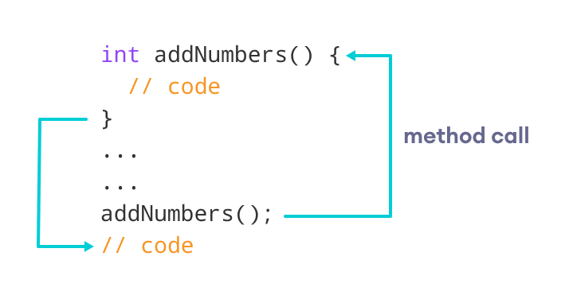
Working of Java Method Call

Example 1: Java Methods
class Main {

// create a method
public int addNumbers(int a, int b) {
int sum = a + b;
// return value
return sum;
}

public static void main(String[] args) {

int num1 = 25;
int num2 = 15;

// create an object of Main
Main obj = new Main();
// calling method
int result = obj.addNumbers(num1, num2);
System.out.println("Sum is: " + result);
}
}
Output
Sum is: 40
In the above example, we have created a method named addNumbers(). The method takes two parameters a and b. Notice the line,
int result = obj.addNumbers(num1, num2);
Here, we have called the method by passing two arguments num1 and num2. Since the method is returning some value, we have stored the value in the result variable.
The method is not static. Hence, we are calling the method using the object of the class.

Java Method Return Type
A Java method may or may not return a value to the function call. We use the return statement to return any value. For example,
int addNumbers() {
...
return sum;
}
Here, we are returning the variable sum. Since the return type of the function is int. The sum variable should be of int type. Otherwise, it will generate an error.

Example 2: Method Return Type
class Main {

// create a method
public static int square(int num) {

// return statement
return num * num;
}

public static void main(String[] args) {
int result;

// call the method
// store returned value to result
result = square(10);

System.out.println("Squared value of 10 is: " + result);
}
}
Output:
Squared value of 10 is: 100
In the above program, we have created a method named square(). The method takes a number as its parameter and returns the square of the number.
Here, we have mentioned the return type of the method as int. Hence, the method should always return an integer value.
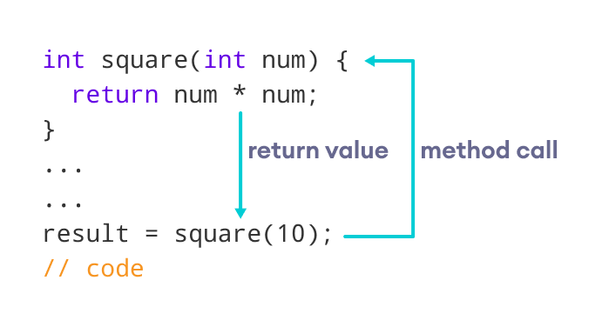
Representation of the Java method returning a value
If the method does not return any value, we use the void keyword as the return type of the method. For example,
public void square(int a) {
int square = a * a;
System.out.println("Square is: " + a);
}

Method Parameters in Java
A method parameter is a value accepted by the method. As mentioned earlier, a method can also have any number of parameters. For example,
// method with two parameters
int addNumbers(int a, int b) {
// code
}

// method with no parameter
int addNumbers(){
// code
}
If a method is created with parameters, we need to pass the corresponding values while calling the method. For example,
// calling the method with two parameters
addNumbers(25, 15);

// calling the method with no parameters
addNumbers()

Example 3: Method Parameters
class Main {

// method with no parameter
public void display1() {
System.out.println("Method without parameter");
}

// method with single parameter
public void display2(int a) {
System.out.println("Method with a single parameter: " + a);
}

public static void main(String[] args) {

// create an object of Main
Main obj = new Main();

// calling method with no parameter
obj.display1();

// calling method with the single parameter
obj.display2(24);
}
}
Output
Method without parameter
Method with a single parameter: 24
Here, the parameter of the method is int. Hence, if we pass any other data type instead of int, the compiler will throw an error. It is because Java is a strongly typed language.
The argument 24 passed to the display2() method during the method call is called the actual argument.
The parameter num accepted by the method definition is known as a formal argument. We need to specify the type of formal arguments. And, the type of actual arguments and formal arguments should always match.

Standard Library Methods
The standard library methods are built-in methods in Java that are readily available for use. These standard libraries come along with the Java Class Library (JCL) in a Java archive (*.jar) file with JVM and JRE.
For example,
- print() is a method of java.io.PrintSteam. The print("...") method prints the string inside quotation marks.
- sqrt() is a method of Math class. It returns the square root of a number.
Here's a working example:

Example 4: Java Standard Library Method
public class Main {
public static void main(String[] args) {

// using the sqrt() method
System.out.print("Square root of 4 is: " + Math.sqrt(4));
}
}
Output:
Square root of 4 is: 2.0

What are the advantages of using methods?
1. The main advantage is code reusability. We can write a method once, and use it multiple times. We do not have to rewrite the entire code each time. Think of it as, "write once, reuse multiple times".

Example 5: Java Method for Code Reusability
public class Main {

// method defined
private static int getSquare(int x){
return x * x;
}

public static void main(String[] args) {
for (int i = 1; i <= 5; i++) {

// method call
int result = getSquare(i);
System.out.println("Square of " + i + " is: " + result);
}
}
}
Output:
Square of 1 is: 1
Square of 2 is: 4
Square of 3 is: 9
Square of 4 is: 16
Square of 5 is: 25
In the above program, we have created the method named getSquare() to calculate the square of a number. Here, the method is used to calculate the square of numbers less than 6.
Hence, the same method is used again and again.
2. Methods make code more readable and easier to debug. Here, the getSquare() method keeps the code to compute the square in a block. Hence, makes it more readable.

Java Constructors

What is a Constructor?
A constructor in Java is similar to a method that is invoked when an object of the class is created.
Unlike Java methods, a constructor has the same name as that of the class and does not have any return type. For example,
class Test {
Test() {
// constructor body
}
}
Here, Test() is a constructor. It has the same name as that of the class and doesn't have a return type.

Example 1: Java Constructor
class Main {
private String name;

// constructor
Main() {
System.out.println("Constructor Called:");
name = "Programiz";
}

public static void main(String[] args) {

// constructor is invoked while
// creating an object of the Main class
Main obj = new Main();
System.out.println("The name is " + obj.name);
}
}
Output:
Constructor Called:
The name is Programiz
In the above example, we have created a constructor named Main(). Inside the constructor, we are initializing the value of the name variable.
Notice the statement of creating an object of the Main class.
Main obj = new Main();
Here, when the object is created, the Main() constructor is called. And, the value of the name variable is initialized.
Hence, the program prints the value of the name variables as Programiz.

Types of Constructor
In Java, constructors can be divided into 3 types:
- No-Arg Constructor
- Parameterized Constructor
- Default Constructor

1. Java No-Arg Constructors
Similar to methods, a Java constructor may or may not have any parameters (arguments).
If a constructor does not accept any parameters, it is known as a no-argument constructor. For example,
private Constructor() {
// body of the constructor
}

Example 2: Java private no-arg constructor
class Main {

int i;

// constructor with no parameter
private Main() {
i = 5;
System.out.println("Constructor is called");
}

public static void main(String[] args) {

// calling the constructor without any parameter
Main obj = new Main();
System.out.println("Value of i: " + obj.i);
}
}
Output:
Constructor is called
Value of i: 5
In the above example, we have created a constructor Main(). Here, the constructor does not accept any parameters. Hence, it is known as a no-arg constructor.
Notice that we have declared the constructor as private.
Once a constructor is declared private, it cannot be accessed from outside the class. So, creating objects from outside the class is prohibited using the private constructor.
Here, we are creating the object inside the same class. Hence, the program is able to access the constructor.
However, if we want to create objects outside the class, then we need to declare the constructor as public.

Example 3: Java public no-arg constructors
class Company {
String name;

// public constructor
public Company() {
name = "Programiz";
}
}

class Main {
public static void main(String[] args) {

// object is created in another class
Company obj = new Company();
System.out.println("Company name = " + obj.name);
}
}
Output:
Company name = Programiz

2. Java Parameterized Constructor
A Java constructor can also accept one or more parameters. Such constructors are known as parameterized constructors (constructor with parameters).

Example 4: Parameterized constructor
class Main {

String languages;

// constructor accepting single value
Main(String lang) {
languages = lang;
System.out.println(languages + " Programming Language");
}

public static void main(String[] args) {

// call constructor by passing a single value
Main obj1 = new Main("Java");
Main obj2 = new Main("Python");
Main obj3 = new Main("C");
}
}
Output:
Java Programming Language
Python Programming Language
C Programming Language
In the above example, we have created a constructor named Main(). Here, the constructor takes a single parameter. Notice the expression,
Main obj1 = new Main("Java");
Here, we are passing the single value to the constructor. Based on the argument passed, the language variable is initialized inside the constructor.

3. Java Default Constructor
If we do not create any constructor, the Java compiler automatically create a no-arg constructor during the execution of the program. This constructor is called default constructor.

Example 5: Default Constructor
class Main {

int a;
boolean b;

public static void main(String[] args) {

// A default constructor is called
Main obj = new Main();

System.out.println("Default Value:");
System.out.println("a = " + obj.a);
System.out.println("b = " + obj.b);
}
}
Output:
a = 0
b = false
Here, we haven't created any constructors. Hence, the Java compiler automatically creates the default constructor.
The default constructor initializes any uninitialized instance variables with default values.
Type | Default Value
boolean | false
byte | 0
short | 0
int | 0
long | 0L
char | \u0000
float | 0.0f
double | 0.0d
object | Reference null
In the above program, the variables a and b are initialized with default value 0 and false respectively.
The above program is equivalent to:
class Main {

int a;
boolean b;

// a private constructor
private Main() {
a = 0;
b = false;
}

public static void main(String[] args) {
// call the constructor
Main obj = new Main();

System.out.println("Default Value:");
System.out.println("a = " + obj.a);
System.out.println("b = " + obj.b);
}
}
The output of the program is the same as Example 5.

Important Notes on Java Constructors
- Constructors are invoked implicitly when you instantiate objects.
- The two rules for creating a constructor are:
The name of the constructor should be the same as the class.
A Java constructor must not have a return type.
- If a class doesn't have a constructor, the Java compiler automatically creates a default constructor during run-time. The default constructor initializes instance variables with default values. For example, the int variable will be initialized to 0
- Constructor types:
No-Arg Constructor - a constructor that does not accept any arguments
Parameterized constructor - a constructor that accepts arguments
Default Constructor - a constructor that is automatically created by the Java compiler if it is not explicitly defined.
- A constructor cannot be abstract or static or final.
- A constructor can be overloaded but can not be overridden.

Constructors Overloading in Java
Similar to Java method overloading, we can also create two or more constructors with different parameters. This is called constructors overloading.

Example 6: Java Constructor Overloading
class Main {

String language;

// constructor with no parameter
Main() {
this.language = "Java";
}

// constructor with a single parameter
Main(String language) {
this.language = language;
}

public void getName() {
System.out.println("Programming Langauage: " + this.language);
}

public static void main(String[] args) {

// call constructor with no parameter
Main obj1 = new Main();

// call constructor with a single parameter
Main obj2 = new Main("Python");

obj1.getName();
obj2.getName();
}
}
Output:
Programming Language: Java
Programming Language: Python
In the above example, we have two constructors: Main() and Main(String language). Here, both the constructor initialize the value of the variable language with different values.
Based on the parameter passed during object creation, different constructors are called and different values are assigned.
It is also possible to call one constructor from another constructor.
We have used this keyword to specify the variable of the class.

Java Strings
In Java, a string is a sequence of characters. For example, "hello" is a string containing a sequence of characters 'h', 'e', 'l', 'l', and 'o'.
We use double quotes to represent a string in Java. For example,
// create a string
String type = "Java programming";
Here, we have created a string variable named type. The variable is initialized with the string Java Programming.

Example: Create a String in Java
class Main {
public static void main(String[] args) {

// create strings
String first = "Java";
String second = "Python";
String third = "JavaScript";

// print strings
System.out.println(first); // print Java
System.out.println(second); // print Python
System.out.println(third); // print JavaScript
}
}
In the above example, we have created three strings named first, second, and third. Here, we are directly creating strings like primitive types.
However, there is another way of creating Java strings (using the new keyword). We will learn about that later in this tutorial.
Strings in Java are not primitive types (like int, char, etc). Instead, all strings are objects of a predefined class named String.
And, all string variables are instances of the String class.

Java String Operations
Java String provides various methods to perform different operations on strings. We will look into some of the commonly used string operations.

1. Get length of a String
To find the length of a string, we use the length() method of the String. For example,
class Main {
public static void main(String[] args) {

// create a string
String greet = "Hello! World";
System.out.println("String: " + greet);

// get the length of greet
int length = greet.length();

System.out.println("Length: " + length);
}
}
Output
String: Hello! World
Length: 12
In the above example, the length() method calculates the total number of characters in the string and returns it.

2. Join Two Java Strings
We can join two strings in Java using the concat() method. For example,
class Main {
public static void main(String[] args) {

// create first string
String first = "Java ";
System.out.println("First String: " + first);

// create second
String second = "Programming";
System.out.println("Second String: " + second);

// join two strings
String joinedString = first.concat(second);

System.out.println("Joined String: " + joinedString);
}
}
Output
First String: Java
Second String: Programming
Joined String: Java Programming
In the above example, we have created two strings named first and second. Notice the statement,
String joinedString = first.concat(second);
Here, the concat() method joins the second string to the first string and assigns it to the joinedString variable.
We can also join two strings using the + operator in Java.

3. Compare two Strings
In Java, we can make comparisons between two strings using the equals() method. For example,
class Main {
public static void main(String[] args) {

// create 3 strings
String first = "java programming";
String second = "java programming";
String third = "python programming";

// compare first and second strings
boolean result1 = first.equals(second);

System.out.println("Strings first and second are equal: " + result1);

// compare first and third strings
boolean result2 = first.equals(third);

System.out.println("Strings first and third are equal: " + result2);
}
}
Output
Strings first and second are equal: true
Strings first and third are equal: false
In the above example, we have created 3 strings named first, second, and third. Here, we are using the equal() method to check if one string is equal to another.
The equals() method checks the content of strings while comparing them.
We can also compare two strings using the == operator in Java. However, this approach is different than the equals() method.

Escape character in Java Strings
The escape character is used to escape some of the characters present inside a string.
Suppose we need to include double quotes inside a string.
// include double quote
String example = "This is the "String" class";
Since strings are represented by double quotes, the compiler will treat "This is the " as the string. Hence, the above code will cause an error.
To solve this issue, we use the escape character \ in Java. For example,
// use the escape character
String example = "This is the \"String\" class.";
Now escape characters tell the compiler to escape double quotes and read the whole text.

Java Strings are Immutable
In Java, strings are immutable. This means, once we create a string, we cannot change that string.
To understand it more deeply, consider an example:
// create a string
String example = "Hello! ";
Here, we have created a string variable named example. The variable holds the string "Hello! ".
Now suppose we want to change the string.
// add another string "World"
// to the previous tring example
example = example.concat(" World");
Here, we are using the concat() method to add another string World to the previous string.
It looks like we are able to change the value of the previous string. However, this is not true.
Let's see what has happened here,
- JVM takes the first string "Hello! "
- creates a new string by adding "World" to the first string
- assign the new string "Hello! World" to the example variable
- the first string "Hello! " remains unchanged

Creating strings using the new keyword
So far we have created strings like primitive types in Java.
Since strings in Java are objects, we can create strings using the new keyword as well. For example,
// create a string using the new keyword
String name = new String("Java String");
In the above example, we have created a string name using the new keyword.
Here, when we create a string object, the String() constructor is invoked.
The String class provides various other constructors to create strings

Example: Create Java Strings using the new keyword
class Main {
public static void main(String[] args) {

// create a string using new
String name = new String("Java String");

System.out.println(name); // print Java String
}
}

Create String using literals vs new keyword
Now that we know how strings are created using string literals and the new keyword, let's see what is the major difference between them.
In Java, the JVM maintains a string pool to store all of its strings inside the memory. The string pool helps in reusing the strings.
1. While creating strings using string literals,
String example = "Java";
Here, we are directly providing the value of the string (Java). Hence, the compiler first checks the string pool to see if the string already exists.
- If the string already exists, the new string is not created. Instead, the new reference, example points to the already existed string (Java).
- If the string doesn't exist, the new string (Java is created.
2. While creating strings using the new keyword,
String example = new String("Java");
Here, the value of the string is not directly provided. Hence, a new "Java" string is created even though "Java" is already present inside the memory pool.

Methods of Java String
Besides those mentioned above, there are various string methods present in Java. Here are some of those methods:
Methods | Description
contains() | checks whether the string contains a substring
substring() | returns the substring of the string
join() | join the given strings using the delimiter
replace() | replaces the specified old character with the specified new character
replaceAll() | replaces all substrings matching the regex pattern
replaceFirst() | replace the first matching substring
charAt() | returns the character present in the specified location
getBytes() | converts the string to an array of bytes
indexOf() | returns the position of the specified character in the string
compareTo() | compares two strings in the dictionary order
compareToIgnoreCase() | compares two strings ignoring case differences
trim() | removes any leading and trailing whitespaces
format() | returns a formatted string
split() | breaks the string into an array of strings
toLowerCase() | converts the string to lowercase
toUpperCase() | converts the string to uppercase
valueOf() | returns the string representation of the specified argument
toCharArray() | converts the string to a char array
matches() | checks whether the string matches the given regex
startsWith() | checks if the string begins with the given string
endsWith() | checks if the string ends with the given string
isEmpty() | checks whether a string is empty of not
intern() | returns the canonical representation of the string
contentEquals() | checks whether the string is equal to charSequence
hashCode() | returns a hash code for the string
subSequence() | returns a subsequence from the string

Java Access Modifiers

What are Access Modifiers?
In Java, access modifiers are used to set the accessibility (visibility) of classes, interfaces, variables, methods, constructors, data members, and the setter methods. For example,
class Animal {
public void method1() {...}

private void method2() {...}
}
In the above example, we have declared 2 methods: method1() and method2(). Here,
- method1 is public - This means it can be accessed by other classes.
- method2 is private - This means it can not be accessed by other classes.
Note the keyword public and private. These are access modifiers in Java. They are also known as visibility modifiers.
You cannot set the access modifier of getters methods.

Types of Access Modifier
There are four access modifiers keywords in Java and they are:
Modifier | Description
Default | declarations are visible only within the package (package private)
Private | declarations are visible within the class only
Protected | declarations are visible within the package or all subclasses
Public | declarations are visible everywhere

Default Access Modifier
If we do not explicitly specify any access modifier for classes, methods, variables, etc, then by default the default access modifier is considered. For example,
package defaultPackage;
class Logger {
void message(){
System.out.println("This is a message");
}
}
Here, the Logger class has the default access modifier. And the class is visible to all the classes that belong to the defaultPackage package. However, if we try to use the Logger class in another class outside of defaultPackage, we will get a compilation error.

Private Access Modifier
When variables and methods are declared private, they cannot be accessed outside of the class. For example,
class Data {
// private variable
private String name;
}

public class Main {
public static void main(String[] main){

// create an object of Data
Data d = new Data();

// access private variable and field from another class
d.name = "Programiz";
}
}
In the above example, we have declared a private variable named name and a private method named display(). When we run the program, we will get the following error:
Main.java:18: error: name has private access in Data
d.name = "Programiz";
^
The error is generated because we are trying to access the private variable and the private method of the Data class from the Main class.
You might be wondering what if we need to access those private variables. In this case, we can use the getters and setters method. For example,
class Data {
private String name;

// getter method
public String getName() {
return this.name;
}
// setter method
public void setName(String name) {
this.name= name;
}
}
public class Main {
public static void main(String[] main){
Data d = new Data();

// access the private variable using the getter and setter
d.setName("Programiz");
System.out.println(d.getName());
}
}
Output:
The name is Programiz
In the above example, we have a private variable named name. In order to access the variable from the outer class, we have used methods: getName() and setName(). These methods are called getter and setter in Java.
Here, we have used the setter method (setName()) to assign value to the variable and the getter method (getName()) to access the variable.
We have used this keyword inside the setName() to refer to the variable of the class.
We cannot declare classes and interfaces private in Java. However, the nested classes can be declared private.

Protected Access Modifier
When methods and data members are declared protected, we can access them within the same package as well as from subclasses. For example,
class Animal {
// protected method
protected void display() {
System.out.println("I am an animal");
}
}

class Dog extends Animal {
public static void main(String[] args) {

// create an object of Dog class
Dog dog = new Dog();
// access protected method
dog.display();
}
}
Output:
I am an animal
In the above example, we have a protected method named display() inside the Animal class. The Animal class is inherited by the Dog class
We then created an object dog of the Dog class. Using the object we tried to access the protected method of the parent class.
Since protected methods can be accessed from the child classes, we are able to access the method of Animal class from the Dog class.
We cannot declare classes or interfaces protected in Java.

Public Access Modifier
When methods, variables, classes, and so on are declared public, then we can access them from anywhere. The public access modifier has no scope restriction. For example,
// Animal.java file
// public class
public class Animal {
// public variable
public int legCount;

// public method
public void display() {
System.out.println("I am an animal.");
System.out.println("I have " + legCount + " legs.");
}
}

// Main.java
public class Main {
public static void main( String[] args ) {
// accessing the public class
Animal animal = new Animal();

// accessing the public variable
animal.legCount = 4;
// accessing the public method
animal.display();
}
}
Output:
I am an animal.
I have 4 legs.
Here,
- The public class Animal is accessed from the Main class.
- The public variable legCount is accessed from the Main class.
- The public method display() is accessed from the Main class.

Access Modifiers Summarized in one figure
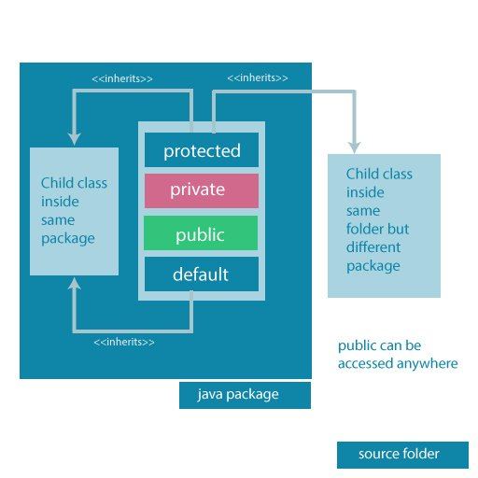
Accessibility of all Access Modifiers in Java
Access modifiers are mainly used for encapsulation. I can help us to control what part of a program can access the members of a class. So that misuse of data can be prevented.

Java this Keyword

this Keyword
In Java, this keyword is used to refer to the current object inside a method or a constructor. For example,
class Main {
int instVar;

Main(int instVar){
this.instVar = instVar;
System.out.println("this reference = " + this);
}

public static void main(String[] args) {
Main obj = new Main(8);
System.out.println("object reference = " + obj);
}
}
Output:
this reference = Main@23fc625e
object reference = Main@23fc625e
In the above example, we created an object named obj of the class Main. We then print the reference to the object obj and this keyword of the class.
Here, we can see that the reference of both obj and this is the same. It means this is nothing but the reference to the current object.

Use of this Keyword
There are various situations where this keyword is commonly used.

Using this for Ambiguity Variable Names
In Java, it is not allowed to declare two or more variables having the same name inside a scope (class scope or method scope). However, instance variables and parameters may have the same name. For example,
class MyClass {
// instance variable
int age;

// parameter
MyClass(int age){
age = age;
}
}
In the above program, the instance variable and the parameter have the same name: age. Here, the Java compiler is confused due to name ambiguity.
In such a situation, we use this keyword. For example,
First, let's see an example without using this keyword:
class Main {

int age;
Main(int age){
age = age;
}

public static void main(String[] args) {
Main obj = new Main(8);
System.out.println("obj.age = " + obj.age);
}
}
Output:
obj.age = 0
In the above example, we have passed 8 as a value to the constructor. However, we are getting 0 as an output. This is because the Java compiler gets confused because of the ambiguity in names between instance the variable and the parameter.
Now, let's rewrite the above code using this keyword.
class Main {

int age;
Main(int age){
this.age = age;
}

public static void main(String[] args) {
Main obj = new Main(8);
System.out.println("obj.age = " + obj.age);
}
}
Output:
obj.age = 8
Now, we are getting the expected output. It is because when the constructor is called, this inside the constructor is replaced by the object obj that has called the constructor. Hence the age variable is assigned value 8.
Also, if the name of the parameter and instance variable is different, the compiler automatically appends this keyword. For example, the code:
class Main {
int age;

Main(int i) {
age = i;
}
}
is equivalent to:
class Main {
int age;

Main(int i) {
this.age = i;
}
}

this with Getters and Setters
Another common use of this keyword is in setters and getters methods of a class. For example:
class Main {
String name;

// setter method
void setName( String name ) {
this.name = name;
}

// getter method
String getName(){
return this.name;
}

public static void main( String[] args ) {
Main obj = new Main();

// calling the setter and the getter method
obj.setName("Toshiba");
System.out.println("obj.name: "+obj.getName());
}
}
Output:
obj.name: Toshiba
Here, we have used this keyword:
- to assign value inside the setter method
- to access value inside the getter method

Using this in Constructor Overloading
While working with constructor overloading, we might have to invoke one constructor from another constructor. In such a case, we cannot call the constructor explicitly. Instead, we have to use this keyword.
Here, we use a different form of this keyword. That is, this(). Let's take an example,
class Complex {

private int a, b;

// constructor with 2 parameters
private Complex( int i, int j ){
this.a = i;
this.b = j;
}

// constructor with single parameter
private Complex(int i){
// invokes the constructor with 2 parameters
this(i, i);
}

// constructor with no parameter
private Complex(){
// invokes the constructor with single parameter
this(0);
}

@Override
public String toString(){
return this.a + " + " + this.b + "i";
}

public static void main( String[] args ) {

// creating object of Complex class
// calls the constructor with 2 parameters
Complex c1 = new Complex(2, 3);

// calls the constructor with a single parameter
Complex c2 = new Complex(3);

// calls the constructor with no parameters
Complex c3 = new Complex();

// print objects
System.out.println(c1);
System.out.println(c2);
System.out.println(c3);
}
}
Output:
2 + 3i
3 + 3i
0 + 0i
In the above example, we have used this keyword,
- to call the constructor Complex(int i, int j) from the constructor Complex(int i)
- to call the constructor Complex(int i) from the constructor Complex()
Notice the line,
System.out.println(c1);
Here, when we print the object c1, the object is converted into a string. In this process, the toString() is called. Since we override the toString() method inside our class, we get the output according to that method.
One of the huge advantages of this() is to reduce the amount of duplicate code. However, we should be always careful while using this().
This is because calling constructor from another constructor adds overhead and it is a slow process. Another huge advantage of using this() is to reduce the amount of duplicate code.
Invoking one constructor from another constructor is called explicit constructor invocation.

Passing this as an Argument
We can use this keyword to pass the current object as an argument to a method. For example,
class ThisExample {
// declare variables
int x;
int y;

ThisExample(int x, int y) {
// assign values of variables inside constructor
this.x = x;
this.y = y;

// value of x and y before calling add()
System.out.println("Before passing this to addTwo() method:");
System.out.println("x = " + this.x + ", y = " + this.y);

// call the add() method passing this as argument
add(this);

// value of x and y after calling add()
System.out.println("After passing this to addTwo() method:");
System.out.println("x = " + this.x + ", y = " + this.y);
}

void add(ThisExample o){
o.x += 2;
o.y += 2;
}
}

class Main {
public static void main( String[] args ) {
ThisExample obj = new ThisExample(1, -2);
}
}
Output:
Before passing this to addTwo() method:
x = 1, y = -2
After passing this to addTwo() method:
x = 3, y = 0
In the above example, inside the constructor ThisExample(), notice the line,
add(this);
Here, we are calling the add() method by passing this as an argument. Since this keyword contains the reference to the object obj of the class, we can change the value of x and y inside the add() method.

Java final keyword
In Java, the final keyword is used to denote constants. It can be used with variables, methods, and classes.
Once any entity (variable, method or class) is declared final, it can be assigned only once. That is,
- the final variable cannot be reinitialized with another value
- the final method cannot be overridden
- the final class cannot be extended

1. Java final Variable
In Java, we cannot change the value of a final variable. For example,
class Main {
public static void main(String[] args) {

// create a final variable
final int AGE = 32;

// try to change the final variable
AGE = 45;
System.out.println("Age: " + AGE);
}
}
In the above program, we have created a final variable named age. And we have tried to change the value of the final variable.
When we run the program, we will get a compilation error with the following message.
cannot assign a value to final variable AGE
AGE = 45;
^
It is recommended to use uppercase to declare final variables in Java.

2. Java final Method
In Java, the final method cannot be overridden by the child class. For example,
class FinalDemo {
// create a final method
public final void display() {
System.out.println("This is a final method.");
}
}

class Main extends FinalDemo {
// try to override final method
public final void display() {
System.out.println("The final method is overridden.");
}

public static void main(String[] args) {
Main obj = new Main();
obj.display();
}
}
In the above example, we have created a final method named display() inside the FinalDemo class. Here, the Main class inherits the FinalDemo class.
We have tried to override the final method in the Main class. When we run the program, we will get a compilation error with the following message.
display() in Main cannot override display() in FinalDemo
public final void display() {
^
overridden method is final

3. Java final Class
In Java, the final class cannot be inherited by another class. For example,
// create a final class
final class FinalClass {
public void display() {
System.out.println("This is a final method.");
}
}

// try to extend the final class
class Main extends FinalClass {
public void display() {
System.out.println("The final method is overridden.");
}

public static void main(String[] args) {
Main obj = new Main();
obj.display();
}
}
In the above example, we have created a final class named FinalClass. Here, we have tried to inherit the final class by the Main class.
When we run the program, we will get a compilation error with the following message.
cannot inherit from final FinalClass
class Main extends FinalClass {
^

Java Recursion
In Java, a method that calls itself is known as a recursive method. And, this process is known as recursion.
A physical world example would be to place two parallel mirrors facing each other. Any object in between them would be reflected recursively.

How Recursion works?
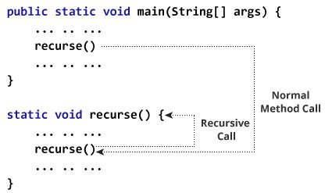
Working of Java Recursion
In the above example, we have called the recurse() method from inside the main method. (normal method call). And, inside the recurse() method, we are again calling the same recurse method. This is a recursive call.
In order to stop the recursive call, we need to provide some conditions inside the method. Otherwise, the method will be called infinitely.
Hence, we use the if...else statement (or similar approach) to terminate the recursive call inside the method.

Example: Factorial of a Number Using Recursion
class Factorial {

static int factorial( int n ) {
if (n != 0) // termination condition
return n * factorial(n-1); // recursive call
else
return 1;
}

public static void main(String[] args) {
int number = 4, result;
result = factorial(number);
System.out.println(number + " factorial = " + result);
}
}
Output:
4 factorial = 24
In the above example, we have a method named factorial(). The factorial() is called from the main() method. with the number variable passed as an argument.
Here, notice the statement,
return n * factorial(n-1);
The factorial() method is calling itself. Initially, the value of n is 4 inside factorial(). During the next recursive call, 3 is passed to the factorial() method. This process continues until n is equal to 0.
When n is equal to 0, the if statement returns false hence 1 is returned. Finally, the accumulated result is passed to the main() method.

Working of Factorial Program
The image below will give you a better idea of how the factorial program is executed using recursion.
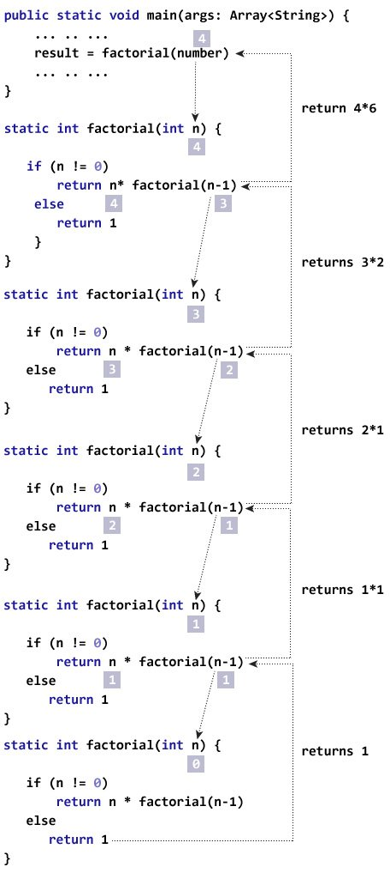
Factorial Program using Recursion

Advantages and Disadvantages of Recursion
When a recursive call is made, new storage locations for variables are allocated on the stack. As, each recursive call returns, the old variables and parameters are removed from the stack. Hence, recursion generally uses more memory and is generally slow.
On the other hand, a recursive solution is much simpler and takes less time to write, debug and maintain.

Java instanceof Operator
The instanceof operator in Java is used to check whether an object is an instance of a particular class or not.
Its syntax is
objectName instanceOf className;
Here, if objectName is an instance of className, the operator returns true. Otherwise, it returns false.

Example: Java instanceof
class Main {

public static void main(String[] args) {

// create a variable of string type
String name = "Programiz";

// checks if name is instance of String
boolean result1 = name instanceof String;
System.out.println("name is an instance of String: " + result1);

// create an object of Main
Main obj = new Main();

// checks if obj is an instance of Main
boolean result2 = obj instanceof Main;
System.out.println("obj is an instance of Main: " + result2);
}
}
Output
name is an instance of String: true
obj is an instance of Main: true
In the above example, we have created a variable name of the String type and an object obj of the Main class.
Here, we have used the instanceof operator to check whether name and obj are instances of the String and Main class respectively. And, the operator returns true in both cases.
In Java, String is a class rather than a primitive data type.

Java instanceof during Inheritance
We can use the instanceof operator to check if objects of the subclass is also an instance of the superclass. For example,
// Java Program to check if an object of the subclass
// is also an instance of the superclass

// superclass
class Animal {
}

// subclass
class Dog extends Animal {
}

class Main {
public static void main(String[] args) {

// create an object of the subclass
Dog d1 = new Dog();

// checks if d1 is an instance of the subclass
System.out.println(d1 instanceof Dog); // prints true

// checks if d1 is an instance of the superclass
System.out.println(d1 instanceof Animal); // prints true
}
}
In the above example, we have created a subclass Dog that inherits from the superclass Animal. We have created an object d1 of the Dog class.
Inside the print statement, notice the expression,
d1 instanceof Animal
Here, we are using the instanceof operator to check whether d1 is also an instance of the superclass Animal.

Java instanceof in Interface
The instanceof operator is also used to check whether an object of a class is also an instance of the interface implemented by the class. For example,
// Java program to check if an object of a class is also
// an instance of the interface implemented by the class

interface Animal {
}

class Dog implements Animal {
}

class Main {
public static void main(String[] args) {

// create an object of the Dog class
Dog d1 = new Dog();

// checks if the object of Dog
// is also an instance of Animal
System.out.println(d1 instanceof Animal); // returns true
}
}
In the above example, the Dog class implements the Animal interface. Inside the print statement, notice the expression,
d1 instanceof Animal
Here, d1 is an instance of Dog class. The instanceof operator checks if d1 is also an instance of the interface Animal.
In Java, all the classes are inherited from the Object class. So, instances of all the classes are also an instance of the Object class.
In the previous example, if we check,
d1 instanceof Object
The result will be true.

Java Inheritance
Inheritance is one of the key features of OOP that allows us to create a new class from an existing class.
The new class that is created is known as subclass (child or derived class) and the existing class from where the child class is derived is known as superclass (parent or base class).
The extends keyword is used to perform inheritance in Java. For example,
class Animal {
// methods and fields
}

// use of extends keyword
// to perform inheritance
class Dog extends Animal {

// methods and fields of Animal
// methods and fields of Dog
}
In the above example, the Dog class is created by inheriting the methods and fields from the Animal class.
Here, Dog is the subclass and Animal is the superclass.

Example 1: Java Inheritance
class Animal {

// field and method of the parent class
String name;
public void eat() {
System.out.println("I can eat");
}
}

// inherit from Animal
class Dog extends Animal {

// new method in subclass
public void display() {
System.out.println("My name is " + name);
}
}

class Main {
public static void main(String[] args) {

// create an object of the subclass
Dog labrador = new Dog();

// access field of superclass
labrador.name = "Rohu";
labrador.display();

// call method of superclass
// using object of subclass
labrador.eat();

}
}
Output
My name is Rohu
I can eat
In the above example, we have derived a subclass Dog from superclass Animal. Notice the statements,
labrador.name = "Rohu";

labrador.eat();
Here, labrador is an object of Dog. However, name and eat() are the members of the Animal class.
Since Dog inherits the field and method from Animal, we are able to access the field and method using the object of the Dog.
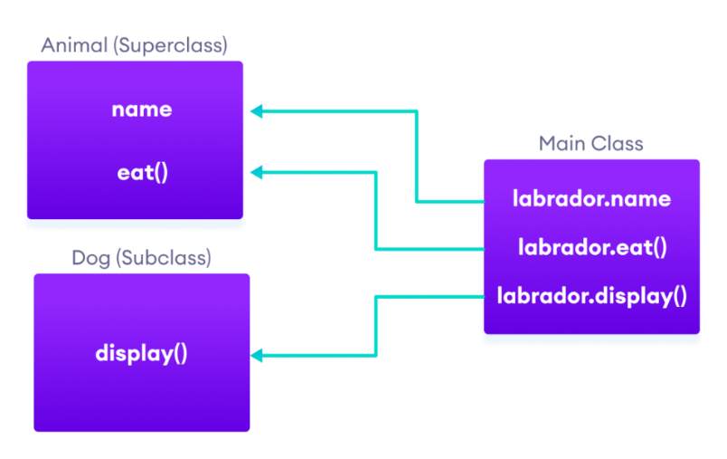
Java Inheritance Implementation

is-a relationship
In Java, inheritance is an is-a relationship. That is, we use inheritance only if there exists an is-a relationship between two classes. For example,
- Car is a Vehicle
- Orange is a Fruit
- Surgeon is a Doctor
- Dog is an Animal
Here, Car can inherit from Vehicle, Orange can inherit from Fruit, and so on.

Method Overriding in Java Inheritance
In Example 1, we see the object of the subclass can access the method of the superclass.
However, if the same method is present in both the superclass and subclass, what will happen?
In this case, the method in the subclass overrides the method in the superclass. This concept is known as method overriding in Java.

Example 2: Method overriding in Java Inheritance
class Animal {

// method in the superclass
public void eat() {
System.out.println("I can eat");
}
}

// Dog inherits Animal
class Dog extends Animal {

// overriding the eat() method
@Override
public void eat() {
System.out.println("I eat dog food");
}

// new method in subclass
public void bark() {
System.out.println("I can bark");
}
}

class Main {
public static void main(String[] args) {

// create an object of the subclass
Dog labrador = new Dog();

// call the eat() method
labrador.eat();
labrador.bark();
}
}
Output
I eat dog food
I can bark
In the above example, the eat() method is present in both the superclass Animal and the subclass Dog.
Here, we have created an object labrador of Dog.
Now when we call eat() using the object labrador, the method inside Dog is called. This is because the method inside the derived class overrides the method inside the base class.
This is called method overriding.
We have used the @Override annotation to tell the compiler that we are overriding a method. However, the annotation is not mandatory.

super Keyword in Java Inheritance
Previously we saw that the same method in the subclass overrides the method in superclass.
In such a situation, the super keyword is used to call the method of the parent class from the method of the child class.

Example 3: super Keyword in Inheritance
class Animal {

// method in the superclass
public void eat() {
System.out.println("I can eat");
}
}

// Dog inherits Animal
class Dog extends Animal {

// overriding the eat() method
@Override
public void eat() {

// call method of superclass
super.eat();
System.out.println("I eat dog food");
}

// new method in subclass
public void bark() {
System.out.println("I can bark");
}
}

class Main {
public static void main(String[] args) {

// create an object of the subclass
Dog labrador = new Dog();

// call the eat() method
labrador.eat();
labrador.bark();
}
}
Output
I can eat
I eat dog food
I can bark
In the above example, the eat() method is present in both the base class Animal and the derived class Dog. Notice the statement,
super.eat();
Here, the super keyword is used to call the eat() method present in the superclass.
We can also use the super keyword to call the constructor of the superclass from the constructor of the subclass.

protected Members in Inheritance
In Java, if a class includes protected fields and methods, then these fields and methods are accessible from the subclass of the class.

Example 4: protected Members in Inheritance
class Animal {
protected String name;

protected void display() {
System.out.println("I am an animal.");
}
}

class Dog extends Animal {

public void getInfo() {
System.out.println("My name is " + name);
}
}

class Main {
public static void main(String[] args) {

// create an object of the subclass
Dog labrador = new Dog();

// access protected field and method
// using the object of subclass
labrador.name = "Rocky";
labrador.display();

labrador.getInfo();
}
}
Output
I am an animal.
My name is Rocky
In the above example, we have created a class named Animal. The class includes a protected field: name and a method: display().
We have inherited the Dog class inherits Animal. Notice the statement,
labrador.name = "Rocky";
labrador.display();
Here, we are able to access the protected field and method of the superclass using the labrador object of the subclass.

Why use inheritance?
- The most important use of inheritance in Java is code reusability. The code that is present in the parent class can be directly used by the child class.
- Method overriding is also known as runtime polymorphism. Hence, we can achieve Polymorphism in Java with the help of inheritance.

Types of inheritance
There are five types of inheritance.

1. Single Inheritance
In single inheritance, a single subclass extends from a single superclass. For example,
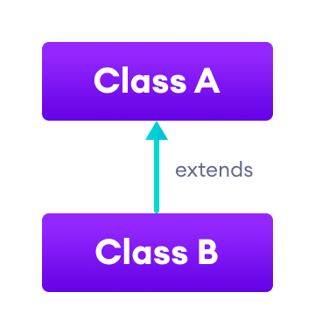
Java Single Inheritance

2. Multilevel Inheritance
In multilevel inheritance, a subclass extends from a superclass and then the same subclass acts as a superclass for another class. For example,
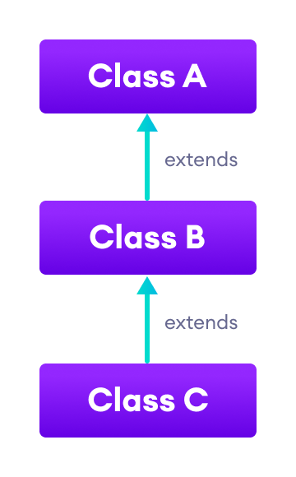
Java Multilevel Inheritance

3. Hierarchical Inheritance
In hierarchical inheritance, multiple subclasses extend from a single superclass. For example,
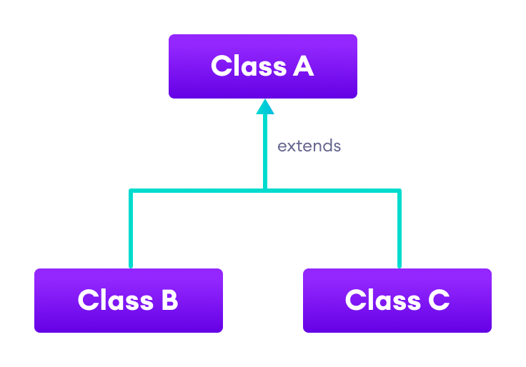J
ava Hierarchical Inheritance

4. Multiple Inheritance
In multiple inheritance, a single subclass extends from multiple superclasses. For example,
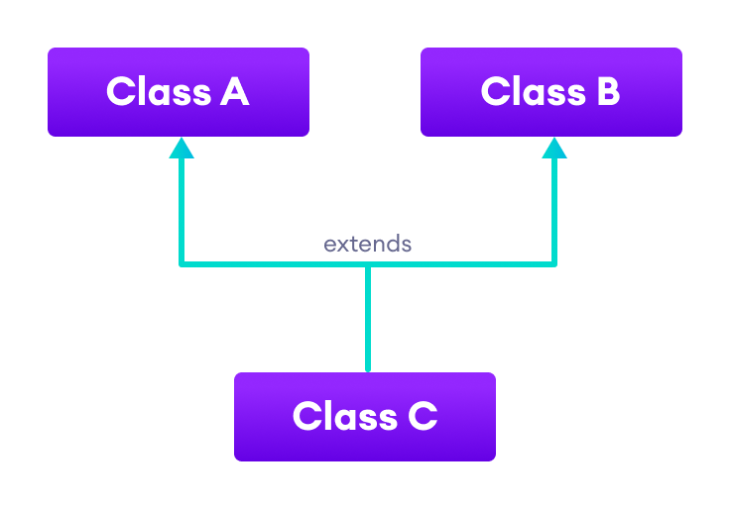
Java Multiple Inheritance
Java doesn't support multiple inheritance. However, we can achieve multiple inheritance using interfaces.

5. Hybrid Inheritance
Hybrid inheritance is a combination of two or more types of inheritance. For example,
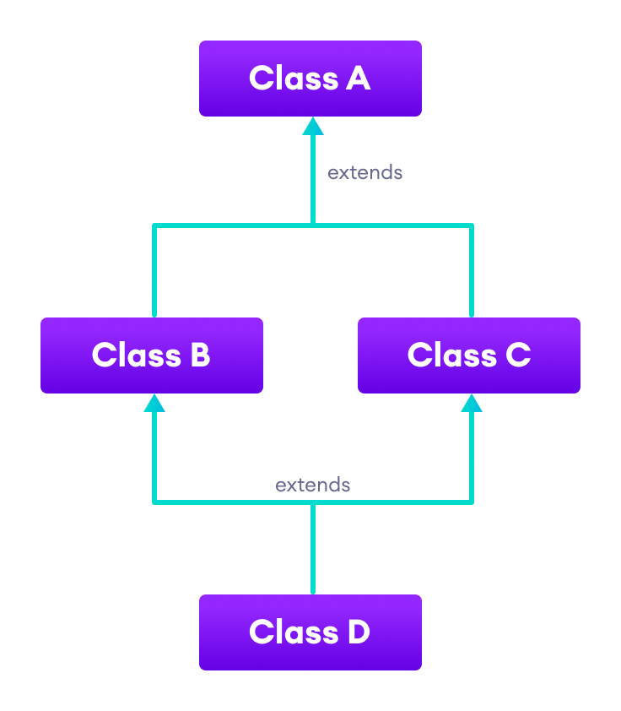

Java Hybrid Inheritance
Here, we have combined hierarchical and multiple inheritance to form a hybrid inheritance.

Java Method Overriding
Inheritance is an OOP property that allows us to derive a new class (subclass) from an existing class (superclass). The subclass inherits the attributes and methods of the superclass.
Now, if the same method is defined in both the superclass and the subclass, then the method of the subclass class overrides the method of the superclass. This is known as method overriding.

Example 1: Method Overriding
class Animal {
public void displayInfo() {
System.out.println("I am an animal.");
}
}

class Dog extends Animal {
@Override
public void displayInfo() {
System.out.println("I am a dog.");
}
}

class Main {
public static void main(String[] args) {
Dog d1 = new Dog();
d1.displayInfo();
}
}
Output:
I am a dog.
In the above program, the displayInfo() method is present in both the Animal superclass and the Dog subclass.
When we call displayInfo() using the d1 object (object of the subclass), the method inside the subclass Dog is called. The displayInfo() method of the subclass overrides the same method of the superclass.
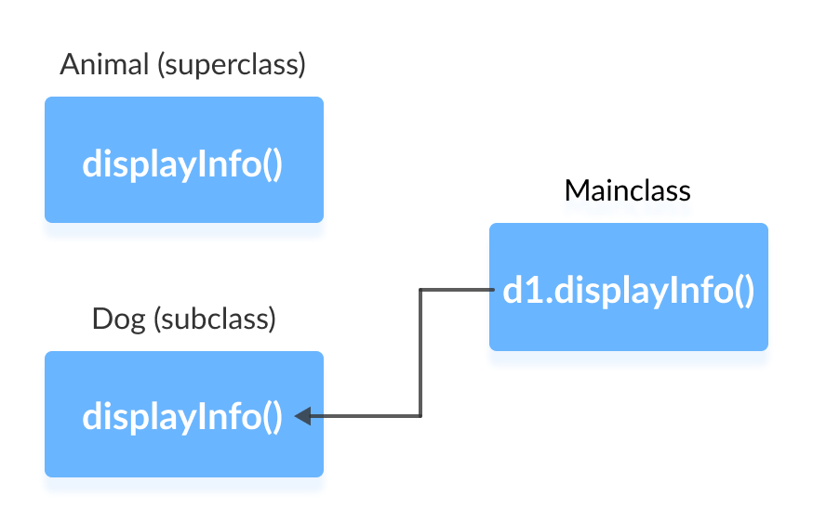
Notice the use of the @Override annotation in our example. In Java, annotations are the metadata that we used to provide information to the compiler. Here, the @Override annotation specifies the compiler that the method after this annotation overrides the method of the superclass.
It is not mandatory to use @Override. However, when we use this, the method should follow all the rules of overriding. Otherwise, the compiler will generate an error.

Java Overriding Rules
- Both the superclass and the subclass must have the same method name, the same return type and the same parameter list.
- We cannot override the method declared as final and static.
- We should always override abstract methods of the superclass (will be discussed in later tutorials).

super Keyword in Java Overriding
A common question that arises while performing overriding in Java is:
To access the method of the superclass from the subclass, we use the super keyword.

Example 2: Use of super Keyword
class Animal {
public void displayInfo() {
System.out.println("I am an animal.");
}
}

class Dog extends Animal {
public void displayInfo() {
super.displayInfo();
System.out.println("I am a dog.");
}
}

class Main {
public static void main(String[] args) {
Dog d1 = new Dog();
d1.displayInfo();
}
}
Output:
I am an animal.
I am a dog.
In the above example, the subclass Dog overrides the method displayInfo() of the superclass Animal.
When we call the method displayInfo() using the d1 object of the Dog subclass, the method inside the Dog subclass is called; the method inside the superclass is not called.
Inside displayInfo() of the Dog subclass, we have used super.displayInfo() to call displayInfo() of the superclass.

It is important to note that constructors in Java are not inherited. Hence, there is no such thing as constructor overriding in Java.
However, we can call the constructor of the superclass from its subclasses. For that, we use super().

Access Specifiers in Method Overriding
The same method declared in the superclass and its subclasses can have different access specifiers. However, there is a restriction.
We can only use those access specifiers in subclasses that provide larger access than the access specifier of the superclass. For example,
Suppose, a method myClass() in the superclass is declared protected. Then, the same method myClass() in the subclass can be either public or protected, but not private.

Example 3: Access Specifier in Overriding
class Animal {
protected void displayInfo() {
System.out.println("I am an animal.");
}
}

class Dog extends Animal {
public void displayInfo() {
System.out.println("I am a dog.");
}
}

class Main {
public static void main(String[] args) {
Dog d1 = new Dog();
d1.displayInfo();
}
}
Output:
I am a dog.
In the above example, the subclass Dog overrides the method displayInfo() of the superclass Animal.
Whenever we call displayInfo() using the d1 (object of the subclass), the method inside the subclass is called.
Notice that, the displayInfo() is declared protected in the Animal superclass. The same method has the public access specifier in the Dog subclass. This is possible because the public provides larger access than the protected.

Overriding Abstract Methods
In Java, abstract classes are created to be the superclass of other classes. And, if a class contains an abstract method, it is mandatory to override it.

Java super
The super keyword in Java is used in subclasses to access superclass members (attributes, constructors and methods).

Uses of super keyword
- To call methods of the superclass that is overridden in the subclass.
- To access attributes (fields) of the superclass if both superclass and subclass have attributes with the same name.
- To explicitly call superclass no-arg (default) or parameterized constructor from the subclass constructor.

1. Access Overridden Methods of the superclass
If methods with the same name are defined in both superclass and subclass, the method in the subclass overrides the method in the superclass.

Example 1: Method overriding
class Animal {

// overridden method
public void display(){
System.out.println("I am an animal");
}
}

class Dog extends Animal {

// overriding method
@Override
public void display(){
System.out.println("I am a dog");
}

public void printMessage(){
display();
}
}

class Main {
public static void main(String[] args) {
Dog dog1 = new Dog();
dog1.printMessage();
}
}
Output
I am a dog
In this example, by making an object dog1 of Dog class, we can call its method printMessage() which then executes the display() statement.
Since display() is defined in both the classes, the method of subclass Dog overrides the method of superclass Animal. Hence, the display() of the subclass is called.
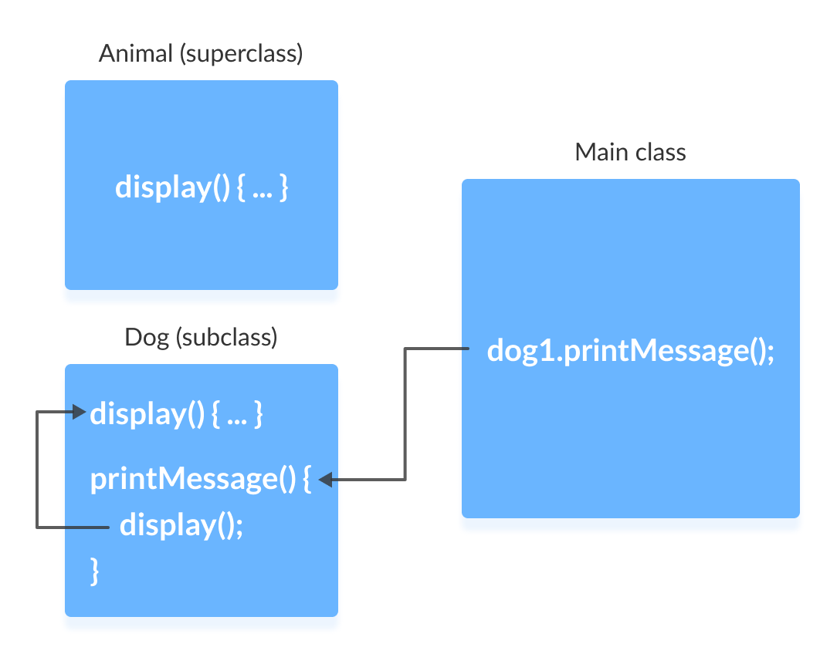

We use super.display() if the overridden method display() of superclass Animal needs to be called.

Example 2: super to Call Superclass Method
class Animal {

// overridden method
public void display(){
System.out.println("I am an animal");
}
}

class Dog extends Animal {

// overriding method
@Override
public void display(){
System.out.println("I am a dog");
}

public void printMessage(){

// this calls overriding method
display();

// this calls overridden method
super.display();
}
}

class Main {
public static void main(String[] args) {
Dog dog1 = new Dog();
dog1.printMessage();
}
}
Output
I am a dog
I am an animal
Here, how the above program works.
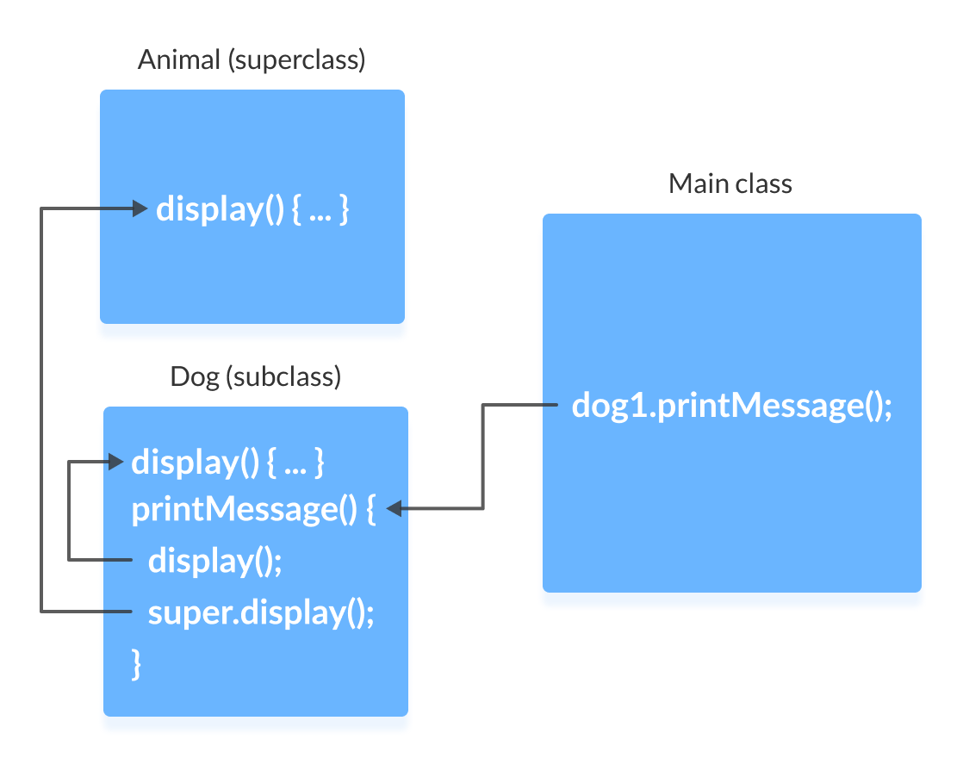

2. Access Attributes of the Superclass
The superclass and subclass can have attributes with the same name. We use the super keyword to access the attribute of the superclass.

Example 3: Access superclass attribute
class Animal {
protected String type="animal";
}

class Dog extends Animal {
public String type="mammal";

public void printType() {
System.out.println("I am a " + type);
System.out.println("I am an " + super.type);
}
}

class Main {
public static void main(String[] args) {
Dog dog1 = new Dog();
dog1.printType();
}
}
Output:
I am a mammal
I am an animal
In this example, we have defined the same instance field type in both the superclass Animal and the subclass Dog.
We then created an object dog1 of the Dog class. Then, the printType() method is called using this object.
Inside the printType() function,
- type refers to the attribute of the subclass Dog.
- super.type refers to the attribute of the superclass Animal.
Hence, System.out.println("I am a " + type); prints I am a mammal. And, System.out.println("I am an " + super.type); prints I am an animal.

3. Use of super() to access superclass constructor
when an object of a class is created, its default constructor is automatically called.
To explicitly call the superclass constructor from the subclass constructor, we use super(). It's a special form of the super keyword.
super() can be used only inside the subclass constructor and must be the first statement.

Example 4: Use of super()
class Animal {

// default or no-arg constructor of class Animal
Animal() {
System.out.println("I am an animal");
}
}

class Dog extends Animal {

// default or no-arg constructor of class Dog
Dog() {

// calling default constructor of the superclass
super();

System.out.println("I am a dog");
}
}

class Main {
public static void main(String[] args) {
Dog dog1 = new Dog();
}
}
Output
I am an animal
I am a dog
Here, when an object dog1 of Dog class is created, it automatically calls the default or no-arg constructor of that class.
Inside the subclass constructor, the super() statement calls the constructor of the superclass and executes the statements inside it. Hence, we get the output I am an animal.
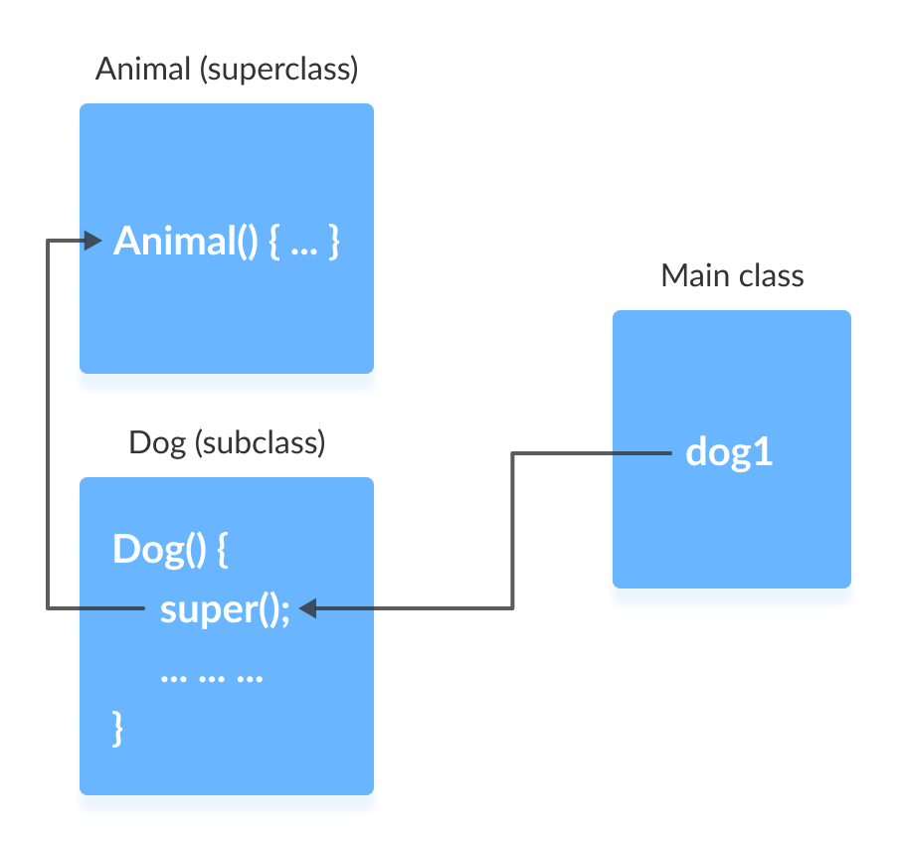
The flow of the program then returns back to the subclass constructor and executes the remaining statements. Thus, I am a dog will be printed.
However, using super() is not compulsory. Even if super() is not used in the subclass constructor, the compiler implicitly calls the default constructor of the superclass.

It is required if the parameterized constructor (a constructor that takes arguments) of the superclass has to be called from the subclass constructor.
The parameterized super() must always be the first statement in the body of the constructor of the subclass, otherwise, we get a compilation error.

Example 5: Call Parameterized Constructor Using super()
class Animal {

// default or no-arg constructor
Animal() {
System.out.println("I am an animal");
}

// parameterized constructor
Animal(String type) {
System.out.println("Type: "+type);
}
}

class Dog extends Animal {

// default constructor
Dog() {

// calling parameterized constructor of the superclass
super("Animal");

System.out.println("I am a dog");
}
}

class Main {
public static void main(String[] args) {
Dog dog1 = new Dog();
}
}
Output
Type: Animal
I am a dog
The compiler can automatically call the no-arg constructor. However, it cannot call parameterized constructors.
If a parameterized constructor has to be called, we need to explicitly define it in the subclass constructor.
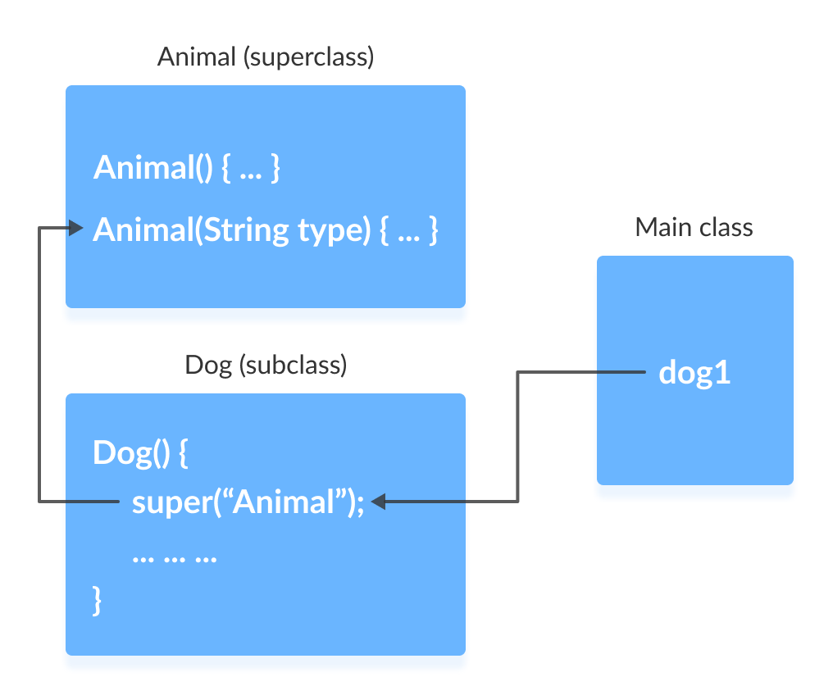
Note that in the above example, we explicitly called the parameterized constructor super("Animal"). The compiler does not call the default constructor of the superclass in this case.

Java Abstract Class and Abstract Methods

Java Abstract Class
The abstract class in Java cannot be instantiated (we cannot create objects of abstract classes). We use the abstract keyword to declare an abstract class. For example,
// create an abstract class
abstract class Language {
// fields and methods
}
...

// try to create an object Language
// throws an error
Language obj = new Language();
An abstract class can have both the regular methods and abstract methods. For example,
abstract class Language {

// abstract method
abstract void method1();

// regular method
void method2() {
System.out.println("This is regular method");
}
}

Java Abstract Method
A method that doesn't have its body is known as an abstract method. We use the same abstract keyword to create abstract methods. For example,
abstract void display();
Here, display() is an abstract method. The body of display() is replaced by ;.
If a class contains an abstract method, then the class should be declared abstract. Otherwise, it will generate an error. For example,
// error
// class should be abstract
class Language {

// abstract method
abstract void method1();
}

Example: Java Abstract Class and Method
Though abstract classes cannot be instantiated, we can create subclasses from it. We can then access members of the abstract class using the object of the subclass. For example,
abstract class Language {

// method of abstract class
public void display() {
System.out.println("This is Java Programming");
}
}

class Main extends Language {

public static void main(String[] args) {

// create an object of Main
Main obj = new Main();

// access method of abstract class
// using object of Main class
obj.display();
}
}
Output
This is Java programming
In the above example, we have created an abstract class named Language. The class contains a regular method display().
We have created the Main class that inherits the abstract class. Notice the statement,
obj.display();
Here, obj is the object of the child class Main. We are calling the method of the abstract class using the object obj.

Implementing Abstract Methods
If the abstract class includes any abstract method, then all the child classes inherited from the abstract superclass must provide the implementation of the abstract method. For example,
abstract class Animal {
abstract void makeSound();

public void eat() {
System.out.println("I can eat.");
}
}

class Dog extends Animal {

// provide implementation of abstract method
public void makeSound() {
System.out.println("Bark bark");
}
}

class Main {
public static void main(String[] args) {

// create an object of Dog class
Dog d1 = new Dog();

d1.makeSound();
d1.eat();
}
}
Output
Bark bark
I can eat.
In the above example, we have created an abstract class Animal. The class contains an abstract method makeSound() and a non-abstract method eat().
We have inherited a subclass Dog from the superclass Animal. Here, the subclass Dog provides the implementation for the abstract method makeSound().
We then used the object d1 of the Dog class to call methods makeSound() and eat().

If the Dog class doesn't provide the implementation of the abstract method makeSound(), Dog should also be declared as abstract. This is because the subclass Dog inherits makeSound() from Animal.

Accesses Constructor of Abstract Classes
An abstract class can have constructors like the regular class. And, we can access the constructor of an abstract class from the subclass using the super keyword. For example,
abstract class Animal {
Animal() {
….
}
}

class Dog extends Animal {
Dog() {
super();
...
}
}
Here, we have used the super() inside the constructor of Dog to access the constructor of the Animal.
super should always be the first statement of the subclass constructor.

Java Abstraction
The major use of abstract classes and methods is to achieve abstraction in Java.
Abstraction is an important concept of object-oriented programming that allows us to hide unnecessary details and only show the needed information.
This allows us to manage complexity by omitting or hiding details with a simpler, higher-level idea.
A practical example of abstraction can be motorbike brakes. We know what brake does. When we apply the brake, the motorbike will stop. However, the working of the brake is kept hidden from us.
The major advantage of hiding the working of the brake is that now the manufacturer can implement brake differently for different motorbikes, however, what brake does will be the same.
Let's take an example that helps us to better understand Java abstraction.

Example 3: Java Abstraction
abstract class MotorBike {
abstract void brake();
}

class SportsBike extends MotorBike {

// implementation of abstract method
public void brake() {
System.out.println("SportsBike Brake");
}
}

class MountainBike extends MotorBike {

// implementation of abstract method
public void brake() {
System.out.println("MountainBike Brake");
}
}

class Main {
public static void main(String[] args) {
MountainBike m1 = new MountainBike();
m1.brake();
SportsBike s1 = new SportsBike();
s1.brake();
}
}
Output:
MountainBike Brake
SportsBike Brake
In the above example, we have created an abstract super class MotorBike. The superclass MotorBike has an abstract method brake().
The brake() method cannot be implemented inside MotorBike. It is because every bike has different implementation of brakes. So, all the subclasses of MotorBike would have different implementation of brake().
So, the implementation of brake() in MotorBike is kept hidden.
Here, MountainBike makes its own implementation of brake() and SportsBike makes its own implementation of brake().

We can also use interfaces to achieve abstraction in Java.

Key Points to Remember
- We use the abstract keyword to create abstract classes and methods.
- An abstract method doesn't have any implementation (method body).
- A class containing abstract methods should also be abstract.
- We cannot create objects of an abstract class.
- To implement features of an abstract class, we inherit subclasses from it and create objects of the subclass.
- A subclass must override all abstract methods of an abstract class. However, if the subclass is declared abstract, it's not mandatory to override abstract methods.
- We can access the static attributes and methods of an abstract class using the reference of the abstract class. For example,
Animal.staticMethod();

Java Interface
An interface is a fully abstract class. It includes a group of abstract methods (methods without a body).
We use the interface keyword to create an interface in Java. For example,
interface Language {
public void getType();

public void getVersion();
}
Here,
- Language is an interface.
- It includes abstract methods: getType() and getVersion().

Implementing an Interface
Like abstract classes, we cannot create objects of interfaces.
To use an interface, other classes must implement it. We use the implements keyword to implement an interface.

Example 1: Java Interface
interface Polygon {
void getArea(int length, int breadth);
}

// implement the Polygon interface
class Rectangle implements Polygon {

// implementation of abstract method
public void getArea(int length, int breadth) {
System.out.println("The area of the rectangle is " + (length * breadth));
}
}

class Main {
public static void main(String[] args) {
Rectangle r1 = new Rectangle();
r1.getArea(5, 6);
}
}
Output
The area of the rectangle is 30
In the above example, we have created an interface named Polygon. The interface contains an abstract method getArea().
Here, the Rectangle class implements Polygon. And, provides the implementation of the getArea() method.

Example 2: Java Interface
// create an interface
interface Language {
void getName(String name);
}

// class implements interface
class ProgrammingLanguage implements Language {

// implementation of abstract method
public void getName(String name) {
System.out.println("Programming Language: " + name);
}
}

class Main {
public static void main(String[] args) {
ProgrammingLanguage language = new ProgrammingLanguage();
language.getName("Java");
}
}
Output
Programming Language: Java
In the above example, we have created an interface named Language. The interface includes an abstract method getName().
Here, the ProgrammingLanguage class implements the interface and provides the implementation for the method.

Implementing Multiple Interfaces
In Java, a class can also implement multiple interfaces. For example,
interface A {
// members of A
}

interface B {
// members of B
}

class C implements A, B {
// abstract members of A
// abstract members of B
}

Extending an Interface
Similar to classes, interfaces can extend other interfaces. The extends keyword is used for extending interfaces. For example,
interface Line {
// members of Line interface
}

// extending interface
interface Polygon extends Line {
// members of Polygon interface
// members of Line interface
}
Here, the Polygon interface extends the Line interface. Now, if any class implements Polygon, it should provide implementations for all the abstract methods of both Line and Polygon.

Extending Multiple Interfaces
An interface can extend multiple interfaces. For example,
interface A {
...
}
interface B {
...
}

interface C extends A, B {
...
}

Advantages of Interface in Java
Now that we know what interfaces are.
- Similar to abstract classes, interfaces help us to achieve abstraction in Java.
Here, we know getArea() calculates the area of polygons but the way area is calculated is different for different polygons. Hence, the implementation of getArea() is independent of one another.
- Interfaces provide specifications that a class (which implements it) must follow.
In our previous example, we have used getArea() as a specification inside the interface Polygon. This is like setting a rule that we should be able to get the area of every polygon.
Now any class that implements the Polygon interface must provide an implementation for the getArea() method.
- Interfaces are also used to achieve multiple inheritance in Java. For example,
- interface Line {
- …
- }

- interface Polygon {
- …
- }

- class Rectangle implements Line, Polygon {
- …
}
Here, the class Rectangle is implementing two different interfaces. This is how we achieve multiple inheritance in Java.
All the methods inside an interface are implicitly public and all fields are implicitly public static final. For example,
interface Language {

// by default public static final
String type = "programming language";

// by default public
void getName();
}

default methods in Java Interfaces
With the release of Java 8, we can now add methods with implementation inside an interface. These methods are called default methods.
To declare default methods inside interfaces, we use the default keyword. For example,
public default void getSides() {
// body of getSides()
}

Why default methods?
Let's take a scenario to understand why default methods are introduced in Java.
Suppose, we need to add a new method in an interface.
We can add the method in our interface easily without implementation. However, that's not the end of the story. All our classes that implement that interface must provide an implementation for the method.
If a large number of classes were implementing this interface, we need to track all these classes and make changes to them. This is not only tedious but error-prone as well.
To resolve this, Java introduced default methods. Default methods are inherited like ordinary methods.
Let's take an example to have a better understanding of default methods.

Example: Default Method in Java Interface
interface Polygon {
void getArea();

// default method
default void getSides() {
System.out.println("I can get sides of a polygon.");
}
}

// implements the interface
class Rectangle implements Polygon {
public void getArea() {
int length = 6;
int breadth = 5;
int area = length * breadth;
System.out.println("The area of the rectangle is " + area);
}

// overrides the getSides()
public void getSides() {
System.out.println("I have 4 sides.");
}
}

// implements the interface
class Square implements Polygon {
public void getArea() {
int length = 5;
int area = length * length;
System.out.println("The area of the square is " + area);
}
}

class Main {
public static void main(String[] args) {

// create an object of Rectangle
Rectangle r1 = new Rectangle();
r1.getArea();
r1.getSides();

// create an object of Square
Square s1 = new Square();
s1.getArea();
s1.getSides();
}
}
Output
The area of the rectangle is 30
I have 4 sides.
The area of the square is 25
I can get sides of a polygon.
In the above example, we have created an interface named Polygon. It has a default method getSides() and an abstract method getArea().
Here, we have created two classes Rectangle and Square that implement Polygon.
The Rectangle class provides the implementation of the getArea() method and overrides the getSides() method. However, the Square class only provides the implementation of the getArea() method.
Now, while calling the getSides() method using the Rectangle object, the overridden method is called. However, in the case of the Square object, the default method is called.

private and static Methods in Interface
The Java 8 also added another feature to include static methods inside an interface.
Similar to a class, we can access static methods of an interface using its references. For example,
// create an interface
interface Polygon {
staticMethod(){..}
}

// access static method
Polygon.staticMethod();
Note: With the release of Java 9, private methods are also supported in interfaces.
We cannot create objects of an interface. Hence, private methods are used as helper methods that provide support to other methods in interfaces.

Practical Example of Interface
Let's see a more practical example of Java Interface.
// To use the sqrt function
import java.lang.Math;

interface Polygon {
void getArea();

// calculate the perimeter of a Polygon
default void getPerimeter(int... sides) {
int perimeter = 0;
for (int side: sides) {
perimeter += side;
}

System.out.println("Perimeter: " + perimeter);
}
}

class Triangle implements Polygon {
private int a, b, c;
private double s, area;

// initializing sides of a triangle
Triangle(int a, int b, int c) {
this.a = a;
this.b = b;
this.c = c;
s = 0;
}

// calculate the area of a triangle
public void getArea() {
s = (double) (a + b + c)/2;
area = Math.sqrt(s*(s-a)*(s-b)*(s-c));
System.out.println("Area: " + area);
}
}

class Main {
public static void main(String[] args) {
Triangle t1 = new Triangle(2, 3, 4);

// calls the method of the Triangle class
t1.getArea();

// calls the method of Polygon
t1.getPerimeter(2, 3, 4);
}
}
Output
Area: 2.9047375096555625
Perimeter: 9
In the above program, we have created an interface named Polygon. It includes a default method getPerimeter() and an abstract method getArea().
We can calculate the perimeter of all polygons in the same manner so we implemented the body of getPerimeter() in Polygon.
Now, all polygons that implement Polygon can use getPerimeter() to calculate perimeter.
However, the rule for calculating the area is different for different polygons. Hence, getArea() is included without implementation.
Any class that implements Polygon must provide an implementation of getArea().

Java Polymorphism
Polymorphism is an important concept of object-oriented programming. It simply means more than one form.
That is, the same entity (method or operator or object) can perform different operations in different scenarios.

Example: Java Polymorphism
class Polygon {

// method to render a shape
public void render() {
System.out.println("Rendering Polygon...");
}
}

class Square extends Polygon {

// renders Square
public void render() {
System.out.println("Rendering Square...");
}
}

class Circle extends Polygon {

// renders circle
public void render() {
System.out.println("Rendering Circle...");
}
}

class Main {
public static void main(String[] args) {

// create an object of Square
Square s1 = new Square();
s1.render();

// create an object of Circle
Circle c1 = new Circle();
c1.render();
}
}
Output
Rendering Square...
Rendering Circle...
In the above example, we have created a superclass: Polygon and two subclasses: Square and Circle. Notice the use of the render() method.
The main purpose of the render() method is to render the shape. However, the process of rendering a square is different than the process of rendering a circle.
Hence, the render() method behaves differently in different classes. Or, we can say render() is polymorphic.

Why Polymorphism?

Polymorphism allows us to create consistent code. In the previous example, we can also create different methods: renderSquare() and renderCircle() to render Square and Circle, respectively.
This will work perfectly. However, for every shape, we need to create different methods. It will make our code inconsistent.
To solve this, polymorphism in Java allows us to create a single method render() that will behave differently for different shapes.
The print() method is also an example of polymorphism. It is used to print values of different types like char, int, string, etc.
We can achieve polymorphism in Java using the following ways:
- Method Overriding
- Method Overloading
- Operator Overloading

Java Method Overriding
During inheritance in Java, if the same method is present in both the superclass and the subclass. Then, the method in the subclass overrides the same method in the superclass. This is called method overriding.
In this case, the same method will perform one operation in the superclass and another operation in the subclass. For example,

Example 1: Polymorphism using method overriding
class Language {
public void displayInfo() {
System.out.println("Common English Language");
}
}

class Java extends Language {
@Override
public void displayInfo() {
System.out.println("Java Programming Language");
}
}

class Main {
public static void main(String[] args) {

// create an object of Java class
Java j1 = new Java();
j1.displayInfo();

// create an object of Language class
Language l1 = new Language();
l1.displayInfo();
}
}
Output:
Java Programming Language
Common English Language
In the above example, we have created a superclass named Language and a subclass named Java. Here, the method displayInfo() is present in both Language and Java.
The use of displayInfo() is to print the information. However, it is printing different information in Language and Java.
Based on the object used to call the method, the corresponding information is printed.
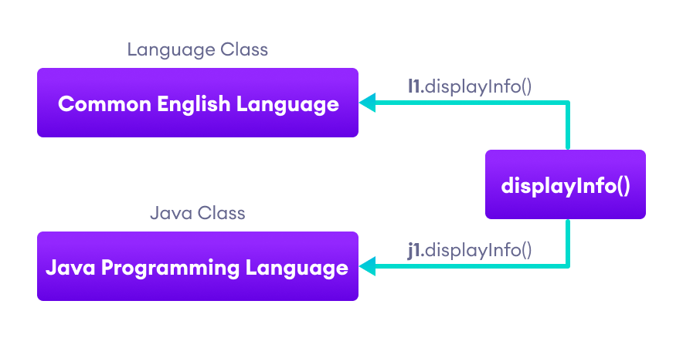
Working of Java Polymorphism
The method that is called is determined during the execution of the program. Hence, method overriding is a run-time polymorphism.

2. Java Method Overloading
In a Java class, we can create methods with the same name if they differ in parameters. For example,
void func() { ... }
void func(int a) { ... }
float func(double a) { ... }
float func(int a, float b) { ... }
This is known as method overloading in Java. Here, the same method will perform different operations based on the parameter.

Example 3: Polymorphism using method overloading
class Pattern {

// method without parameter
public void display() {
for (int i = 0; i < 10; i++) {
System.out.print("*");
}
}

// method with single parameter
public void display(char symbol) {
for (int i = 0; i < 10; i++) {
System.out.print(symbol);
}
}
}

class Main {
public static void main(String[] args) {
Pattern d1 = new Pattern();

// call method without any argument
d1.display();
System.out.println("\n");

// call method with a single argument
d1.display('#');
}
}
Output:
**********

##########
In the above example, we have created a class named Pattern. The class contains a method named display() that is overloaded.
// method with no arguments
display() {...}

// method with a single char type argument
display(char symbol) {...}
Here, the main function of display() is to print the pattern. However, based on the arguments passed, the method is performing different operations:
- prints a pattern of *, if no argument is passed or
- prints pattern of the parameter, if a single char type argument is passed.
The method that is called is determined by the compiler. Hence, it is also known as compile-time polymorphism.

3. Java Operator Overloading
Some operators in Java behave differently with different operands. For example,
- + operator is overloaded to perform numeric addition as well as string concatenation, and
- operators like &, |, and ! are overloaded for logical and bitwise operations.
Let's see how we can achieve polymorphism using operator overloading.
The + operator is used to add two entities. However, in Java, the + operator performs two operations.
1. When + is used with numbers (integers and floating-point numbers), it performs mathematical addition. For example,
int a = 5;
int b = 6;

// + with numbers
int sum = a + b; // Output = 11
2. When we use the + operator with strings, it will perform string concatenation (join two strings). For example,
String first = "Java ";
String second = "Programming";

// + with strings
name = first + second; // Output = Java Programming
Here, we can see that the + operator is overloaded in Java to perform two operations: addition and concatenation.

In languages like C++, we can define operators to work differently for different operands. However, Java doesn't support user-defined operator overloading.

Polymorphic Variables
A variable is called polymorphic if it refers to different values under different conditions.
Object variables (instance variables) represent the behavior of polymorphic variables in Java. It is because object variables of a class can refer to objects of its class as well as objects of its subclasses.

Example: Polymorphic Variables
class ProgrammingLanguage {
public void display() {
System.out.println("I am Programming Language.");
}
}

class Java extends ProgrammingLanguage {
@Override
public void display() {
System.out.println("I am Object-Oriented Programming Language.");
}
}

class Main {
public static void main(String[] args) {

// declare an object variable
ProgrammingLanguage pl;

// create object of ProgrammingLanguage
pl = new ProgrammingLanguage();
pl.display();

// create object of Java class
pl = new Java();
pl.display();
}
}
Output:
I am Programming Language.
I am Object-Oriented Programming Language.
In the above example, we have created an object variable pl of the ProgrammingLanguage class. Here, pl is a polymorphic variable. This is because,
- In statement pl = new ProgrammingLanguage(), pl refer to the object of the ProgrammingLanguage class.
- And, in statement pl = new Java(), pl refer to the object of the Java class.
This is an example of upcasting in Java.

Java Encapsulation
In this tutorial, you will learn about encapsulation and data hiding in Java with the help of examples.

Java Encapsulation
Encapsulation is one of the key features of object-oriented programming. Encapsulation refers to the bundling of fields and methods inside a single class.
It prevents outer classes from accessing and changing fields and methods of a class. This also helps to achieve data hiding.

Example 1: Java Encapsulation
class Area {

// fields to calculate area
int length;
int breadth;

// constructor to initialize values
Area(int length, int breadth) {
this.length = length;
this.breadth = breadth;
}

// method to calculate area
public void getArea() {
int area = length * breadth;
System.out.println("Area: " + area);
}
}

class Main {
public static void main(String[] args) {

// create object of Area
// pass value of length and breadth
Area rectangle = new Area(5, 6);
rectangle.getArea();
}
}
Output
Area: 30
In the above example, we have created a class named Area. The main purpose of this class is to calculate the area.
To calculate an area, we need two variables: length and breadth and a method: getArea(). Hence, we bundled these fields and methods inside a single class.
Here, the fields and methods can be accessed from other classes as well. Hence, this is not data hiding.
This is only encapsulation. We are just keeping similar codes together.
Note: People often consider encapsulation as data hiding, but that's not entirely true.
Encapsulation refers to the bundling of related fields and methods together. This can be used to achieve data hiding. Encapsulation in itself is not data hiding.

Why Encapsulation?
- In Java, encapsulation helps us to keep related fields and methods together, which makes our code cleaner and easy to read.
- It helps to control the values of our data fields. For example,
- class Person {
- private int age;

- public void setAge(int age) {
- if (age >= 0) {
- this.age = age;
- }
- }
}
Here, we are making the age variable private and applying logic inside the setAge() method. Now, age cannot be negative.
- The getter and setter methods provide read-only or write-only access to our class fields. For example,
- getName() // provides read-only access
setName() // provides write-only access
- It helps to decouple components of a system. For example, we can encapsulate code into multiple bundles.
These decoupled components (bundle) can be developed, tested, and debugged independently and concurrently. And, any changes in a particular component do not have any effect on other components.
- We can also achieve data hiding using encapsulation. In the above example, if we change the length and breadth variable into private, then the access to these fields is restricted.
And, they are kept hidden from outer classes. This is called data hiding.

Data Hiding
Data hiding is a way of restricting the access of our data members by hiding the implementation details. Encapsulation also provides a way for data hiding.
We can use access modifiers to achieve data hiding. For example,

Example 2: Data hiding using the private specifier
class Person {

// private field
private int age;

// getter method
public int getAge() {
return age;
}

// setter method
public void setAge(int age) {
this.age = age;
}
}

class Main {
public static void main(String[] args) {

// create an object of Person
Person p1 = new Person();

// change age using setter
p1.setAge(24);

// access age using getter
System.out.println("My age is " + p1.getAge());
}
}
Output
My age is 24
In the above example, we have a private field age. Since it is private, it cannot be accessed from outside the class.
In order to access age, we have used public methods: getAge() and setAge(). These methods are called getter and setter methods.
Making age private allowed us to restrict unauthorized access from outside the class. This is data hiding.
If we try to access the age field from the Main class, we will get an error.
// error: age has private access in Person
p1.age = 24;

Java Nested and Inner Class
In this tutorial, you will learn about the nested class in Java and its types with the help of examples.
In Java, you can define a class within another class. Such class is known as nested class. For example,
class OuterClass {
// ...
class NestedClass {
// ...
}
}
There are two types of nested classes you can create in Java.
- Non-static nested class (inner class)
- Static nested class

Non-Static Nested Class (Inner Class)
A non-static nested class is a class within another class. It has access to members of the enclosing class (outer class). It is commonly known as inner class.
Since the inner class exists within the outer class, you must instantiate the outer class first, in order to instantiate the inner class.
Here's an example of how you can declare inner classes in Java.

Example 1: Inner class
class CPU {
double price;
// nested class
class Processor{

// members of nested class
double cores;
String manufacturer;

double getCache(){
return 4.3;
}
}

// nested protected class
protected class RAM{

// members of protected nested class
double memory;
String manufacturer;

double getClockSpeed(){
return 5.5;
}
}
}

public class Main {
public static void main(String[] args) {

// create object of Outer class CPU
CPU cpu = new CPU();

// create an object of inner class Processor using outer class
CPU.Processor processor = cpu.new Processor();

// create an object of inner class RAM using outer class CPU
CPU.RAM ram = cpu.new RAM();
System.out.println("Processor Cache = " + processor.getCache());
System.out.println("Ram Clock speed = " + ram.getClockSpeed());
}
}
Output:
Processor Cache = 4.3
Ram Clock speed = 5.5
In the above program, there are two nested classes: Processor and RAM inside the outer class: CPU. We can declare the inner class as protected. Hence, we have declared the RAM class as protected.
Inside the Main class,
- we first created an instance of an outer class CPU named cpu.
- Using the instance of the outer class, we then created objects of inner classes:
- CPU.Processor processor = cpu.new Processor;

CPU.RAM ram = cpu.new RAM();
We use the dot (.) operator to create an instance of the inner class using the outer class.

Accessing Members of Outer Class within Inner Class
We can access the members of the outer class by using this keyword. If you want to learn about this keyword, visit Java this keyword.

Example 2: Accessing Members
class Car {
String carName;
String carType;

// assign values using constructor
public Car(String name, String type) {
this.carName = name;
this.carType = type;
}

// private method
private String getCarName() {
return this.carName;
}

// inner class
class Engine {
String engineType;
void setEngine() {

// Accessing the carType property of Car
if(Car.this.carType.equals("4WD")){

// Invoking method getCarName() of Car
if(Car.this.getCarName().equals("Crysler")) {
this.engineType = "Smaller";
} else {
this.engineType = "Bigger";
}

}else{
this.engineType = "Bigger";
}
}
String getEngineType(){
return this.engineType;
}
}
}

public class Main {
public static void main(String[] args) {

// create an object of the outer class Car
Car car1 = new Car("Mazda", "8WD");

// create an object of inner class using the outer class
Car.Engine engine = car1.new Engine();
engine.setEngine();
System.out.println("Engine Type for 8WD= " + engine.getEngineType());

Car car2 = new Car("Crysler", "4WD");
Car.Engine c2engine = car2.new Engine();
c2engine.setEngine();
System.out.println("Engine Type for 4WD = " + c2engine.getEngineType());
}
}
Output:
Engine Type for 8WD= Bigger
Engine Type for 4WD = Smaller
In the above program, we have the inner class named Engine inside the outer class Car. Here, notice the line,
if(Car.this.carType.equals("4WD")) {...}
We are using this keyword to access the carType variable of the outer class. You may have noticed that instead of using this.carType we have used Car.this.carType.
It is because if we had not mentioned the name of the outer class Car, then this keyword will represent the member inside the inner class.
Similarly, we are also accessing the method of the outer class from the inner class.
if (Car.this.getCarName().equals("Crysler") {...}
It is important to note that, although the getCarName() is a private method, we are able to access it from the inner class.

Static Nested Class
In Java, we can also define a static class inside another class. Such class is known as static nested class. Static nested classes are not called static inner classes.
Unlike inner class, a static nested class cannot access the member variables of the outer class. It is because the static nested class doesn't require you to create an instance of the outer class.
OuterClass.NestedClass obj = new OuterClass.NestedClass();
Here, we are creating an object of the static nested class by simply using the class name of the outer class. Hence, the outer class cannot be referenced using OuterClass.this.

Example 3: Static Inner Class
class MotherBoard {

// static nested class
static class USB{
int usb2 = 2;
int usb3 = 1;
int getTotalPorts(){
return usb2 + usb3;
}
}

}
public class Main {
public static void main(String[] args) {

// create an object of the static nested class
// using the name of the outer class
MotherBoard.USB usb = new MotherBoard.USB();
System.out.println("Total Ports = " + usb.getTotalPorts());
}
}
Output:
Total Ports = 3
In the above program, we have created a static class named USB inside the class MotherBoard. Notice the line,
MotherBoard.USB usb = new MotherBoard.USB();
Here, we are creating an object of USB using the name of the outer class.
Now, let's see what would happen if you try to access the members of the outer class:

Example 4: Accessing members of Outer class inside Static Inner Class
class MotherBoard {
String model;
public MotherBoard(String model) {
this.model = model;
}

// static nested class
static class USB{
int usb2 = 2;
int usb3 = 1;
int getTotalPorts(){
// accessing the variable model of the outer classs
if(MotherBoard.this.model.equals("MSI")) {
return 4;
}
else {
return usb2 + usb3;
}
}
}
}
public class Main {
public static void main(String[] args) {

// create an object of the static nested class
MotherBoard.USB usb = new MotherBoard.USB();
System.out.println("Total Ports = " + usb.getTotalPorts());
}
}
When we try to run the program, we will get an error:
error: non-static variable this cannot be referenced from a static context
This is because we are not using the object of the outer class to create an object of the inner class. Hence, there is no reference to the outer class Motherboard stored in Motherboard.this.

Key Points to Remember
- Java treats the inner class as a regular member of a class. They are just like methods and variables declared inside a class.
- Since inner classes are members of the outer class, you can apply any access modifiers like private, protected to your inner class which is not possible in normal classes.
- Since the nested class is a member of its enclosing outer class, you can use the dot (.) notation to access the nested class and its members.
- Using the nested class will make your code more readable and provide better encapsulation.
- Non-static nested classes (inner classes) have access to other members of the outer/enclosing class, even if they are declared private.

Java Nested Static Class
In this tutorial, you will learn about nested static class with the help of examples. You will also learn about how static classes differs from inner classes.
we can have a class inside another class in Java. Such classes are known as nested classes. In Java, nested classes are of two types:
- Nested non-static class (Inner class)
- Nested static class.

Java Nested Static Class
We use the keyword static to make our nested class static.
In Java, only nested classes are allowed to be static.
Like regular classes, static nested classes can include both static and non-static fields and methods. For example,
Class Animal {
static class Mammal {
// static and non-static members of Mammal
}
// members of Animal
}
Static nested classes are associated with the outer class.
To access the static nested class, we don’t need objects of the outer class.

Example: Static Nested Class
class Animal {

// inner class
class Reptile {
public void displayInfo() {
System.out.println("I am a reptile.");
}
}

// static class
static class Mammal {
public void displayInfo() {
System.out.println("I am a mammal.");
}
}
}

class Main {
public static void main(String[] args) {
// object creation of the outer class
Animal animal = new Animal();

// object creation of the non-static class
Animal.Reptile reptile = animal.new Reptile();
reptile.displayInfo();

// object creation of the static nested class
Animal.Mammal mammal = new Animal.Mammal();
mammal.displayInfo();

}
}
Output
I am a reptile.
I am a mammal.
In the above program, we have two nested class Mammal and Reptile inside a class Animal.
To create an object of the non-static class Reptile, we have used
Animal.Reptile reptile = animal.new Reptile()
To create an object of the static class Mammal, we have used
Animal.Mammal mammal = new Animal.Mammal()

Accessing Members of Outer Class
In Java, static nested classes are associated with the outer class. This is why static nested classes can only access the class members (static fields and methods) of the outer class.
Let’s see what will happen if we try to access non-static fields and methods of the outer class.

Example: Accessing Non-static members
class Animal {
static class Mammal {
public void displayInfo() {
System.out.println("I am a mammal.");
}
}

class Reptile {
public void displayInfo() {
System.out.println("I am a reptile.");
}
}

public void eat() {
System.out.println("I eat food.");
}
}

class Main {
public static void main(String[] args) {
Animal animal = new Animal();
Animal.Reptile reptile = animal.new Reptile();
reptile.displayInfo();

Animal.Mammal mammal = new Animal.Mammal();
mammal.displayInfo();
mammal.eat();
}
}
Output
Main.java:28: error: cannot find symbol
mammal.eat();
^
symbol: method eat()
location: variable mammal of type Mammal
1 error
compiler exit status 1
In the above example, we have created a non-static method eat() inside the class Animal.
Now, if we try to access eat() using the object mammal, the compiler shows an error.
It is because mammal is an object of a static class and we cannot access non-static methods from static classes.

Static Top-level Class
As mentioned above, only nested classes can be static. We cannot have static top-level classes.
Let’s see what will happen if we try to make a top-level class static.
static class Animal {
public static void displayInfo() {
System.out.println("I am an animal");
}
}

class Main {
public static void main(String[] args) {
Animal.displayInfo();
}
}
Output
Main.java:1: error: modifier static not allowed here
static class Animal {
^
1 error
compiler exit status 1
In the above example, we have tried to create a static class Animal. Since Java doesn’t allow static top-level class, we will get an error.

Java Anonymous Class
In this tutorial, you will learn about anonymous classes in Java with the help of examples.
In Java, a class can contain another class known as nested class. It's possible to create a nested class without giving any name.
A nested class that doesn't have any name is known as an anonymous class.
An anonymous class must be defined inside another class. Hence, it is also known as an anonymous inner class. Its syntax is:
class outerClass {

// defining anonymous class
object1 = new Type(parameterList) {
// body of the anonymous class
};
}
Anonymous classes usually extend subclasses or implement interfaces.
Here, Type can be
- a superclass that an anonymous class extends
- an interface that an anonymous class implements
The above code creates an object, object1, of an anonymous class at runtime.
Note: Anonymous classes are defined inside an expression. So, the semicolon is used at the end of anonymous classes to indicate the end of the expression.

Example 1: Anonymous Class Extending a Class
class Polygon {
public void display() {
System.out.println("Inside the Polygon class");
}
}

class AnonymousDemo {
public void createClass() {

// creation of anonymous class extending class Polygon
Polygon p1 = new Polygon() {
public void display() {
System.out.println("Inside an anonymous class.");
}
};
p1.display();
}
}

class Main {
public static void main(String[] args) {
AnonymousDemo an = new AnonymousDemo();
an.createClass();
}
}
Output
Inside an anonymous class.
In the above example, we have created a class Polygon. It has a single method display().
We then created an anonymous class that extends the class Polygon and overrides the display() method.
When we run the program, an object p1 of the anonymous class is created. The object then calls the display() method of the anonymous class.

Example 2: Anonymous Class Implementing an Interface
interface Polygon {
public void display();
}

class AnonymousDemo {
public void createClass() {

// anonymous class implementing interface
Polygon p1 = new Polygon() {
public void display() {
System.out.println("Inside an anonymous class.");
}
};
p1.display();
}
}

class Main {
public static void main(String[] args) {
AnonymousDemo an = new AnonymousDemo();
an.createClass();
}
}
Output
Inside an anonymous class.
In the above example, we have created an anonymous class that implements the Polygon interface.

Advantages of Anonymous Classes
In anonymous classes, objects are created whenever they are required. That is, objects are created to perform some specific tasks. For example,
Object = new Example() {
public void display() {
System.out.println("Anonymous class overrides the method display().");
}
};
Here, an object of the anonymous class is created dynamically when we need to override the display() method.
Anonymous classes also help us to make our code concise.

